**Prof.V.B.Shah Institute of Management & R.V.Patel College of Commerce (Eng.Med.) &**

**V.L.Shah College of Commerce (Guj.Med.) &**

**Sutex Bank College of Computer Applications &**

**Science, Amroli**

**(Accredited ‘B’ (CGPA 2.55) by NAAC Dec.-2009)**

**VEER NARMAD SOUTH GUJARAT UNIVERSITY, SURAT.**



**PROJECT REPORT**

**ON**

**Agriculture Management App**

**SUBMITED BY: Guided By:**

**Hiren.m.Bhalani Priyanka.D.Chauhan**

**Roll no:747**

**Exam no:5125**



**Index**

|  |  |  |
| --- | --- | --- |
| Sr.  No. | Chapters | Page No. |
| 1 | **Introduction**   * 1. Overview   2. Project profile | 4 |
| 2 | **Objectives** | 8 |
| 3 | **System Flow Diagram** | 9 |
| 4 | **DFD / UML Diagram** | 11 |
| 5 | **ER diagram** | 14 |
| 6 | **Database Design** | 16 |
| 7 | **File Listing** | 24 |
| 8 | **System Design** | 27 |
| 9 | **References** | 62 |

**1.Introduction**

* 1. **Overview**

Welcome to AgroCare, your revolutionary Android app designed to redefine how farmers connect, manage resources, trade, and stay informed in the agricultural landscape. With an unwavering focus on delivering a seamless user experience and real-time interactions, AgroCare stands as your all-inclusive solution, empowering farmers to thrive in every aspect of their farming journey.

**1. Cultivating Connections for Collective Growth**

AgroCare isn't just an app; it's a dynamic farming community where cultivators unite to connect, share knowledge, and learn together. Our intuitive social networking feature allows farmers to build relationships, exchange insights, and collaborate on best practices. Whether you're a seasoned farmer or a novice, AgroCare cultivates a sense of unity that elevates your farming endeavours.

**2. Efficient Worker Management**

Efficient worker management is vital for farm operations. AgroCare streamlines this process by facilitating worker recruitment, allowing you to post job listings, review worker profiles, and hire worker with the right skills for your tasks. Our app ensures that your workforce is skilled, available, and ready to contribute to your farm's success.

**3. Seamlessly Bridging Trade and Commerce**

AgroCare provides a platform for farmers to sell their agricultural produce, livestock, and even repurpose used tools and accessories. This simplified trading process enables farmers to showcase their products and connect directly with buyers. From fresh harvests to outgrown equipment, you can effortlessly find interested buyers within the app, enhancing your profitability.

**4. Convenient Procurement for Enhanced Productivity**

From seeds and fertilizers to machinery and tools, AgroCare offers a streamlined shopping experience for all your agricultural needs. Explore a curated selection of products from trusted sellers and make purchases that contribute to your farm's growth. Our platform simplifies the procurement process, saving you time and resources.

**5. Informed Decision-Making**

AgroCare keeps you informed with real-time weather updates, government schemes, and the latest news impacting the agricultural sector. Access accurate weather forecasts to make informed decisions about your crops. Stay updated on government initiatives that could benefit your farm and remain ahead of the curve with the latest industry trends.

**6. Bridging Languages, Fostering Unity**

AgroCare acknowledges India's linguistic diversity, offering the app in 12 local languages. Our commitment to inclusivity ensures that every farmer, regardless of language, can harness the app's potential and benefits.

**7. Real-Time Integration with Firebase**

AgroCare leverages the power of real-time Firebase database technology to provide you with a seamless and dynamic user experience. Enjoy instant updates, swift information sharing, and an app that feels alive and responsive.

AgroCare isn't just an app; it's your ally in cultivating prosperity. Join us in revolutionizing Indian agriculture through connectivity and innovation. Experience the synergy of seamless connections, efficient resource management, amplified trade opportunities, and vital insights with AgroCare.

❖ Student management system have contained three panels:

✓ User panel

✓ Admin panel

* **User Panel**
* **User is a heart of system.**
* **User have to login through mobile number**
* **User can choose language of their choice.**
* **User can add, delete Feed and also respond to other user’s post.**
* **User can add vacancy and also see vacancy published by other users.**
* **User can maintain wages detail. moreover, an sms will be sent to specified worker ‘s mobile no when wage entry is made.**
* **User can sell animals, cultivation products, tools&equipment.**
* **User will get information on weather, government scheme, latest agriculture news.**
* **User can buy all their agriculture need from our e commerce store.**
* **User can also update/delete data related to him.**
* **Admin Panel**
* **Admin is responsible for regulation of system.**
* **Admin have to login through mobile number**
* **Admin can view all the users and user specific data.**
* **Admin is responsible for adding news, government schemes.**
* **Admin will add product in e commerce store and can see orders according to date.**
* **Admin has power to delete/alter resell data.**
  1. **Project Profile**

|  |  |
| --- | --- |
| Agriculture Management System | |
| Project title: | Agriculture Management System |
| Project Label: | AgroCare |
| Package Name: | com.project.agriculturemanagmentapp |
| Frontend: | X.M.L. |
| Backend: | Java, Firebase |
| Operating system: | android |
| Platform: | Android studio, firebase console |
| Documentation tool: | Microsoft word,Draw.io |
| APK Size: | 23.4 MB (2,45,92,384 bytes) |
| Target SDK Version: | 33 |
| Minimum SDK  Version: | 26 |
| Android Gradle Plugin Version: | 8.0.2 |
| Approx Lines:  (GitHub) | 33,075 |
| Start Date:  (GitHub) | Aug 12, 2023. |
| End Date:  (GitHub) | Sep 11, 2023. |
| Api Key: | c19c16e82898cc7627f4e02e485861de |
| Api Provider: | Openweathermap.org |
| Internal Guide: | Priyanka.D.Chauhan |
| Submitted to: | Priyanka.D.Chauhan |

**2. Objectives**

**Start to End Process:**

1. Collecting information for system (Requirement Gathering and Analysis).

2. Preparing the design of the system through information.

3. Creating model class definition and implementation.

4. Integration of Front-end and Back-end.

5. Custom Functions & Validations.

6. Making responsive design.

7. Testing.

8. Debugging and code optimization.

**3. System Flow Diagram**

* 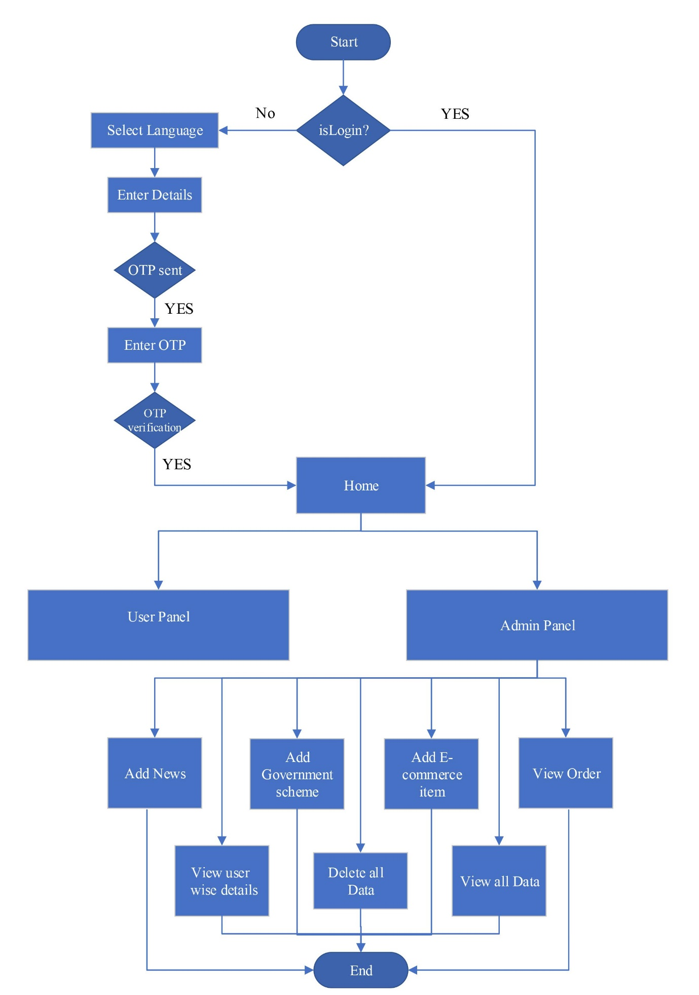**Admin Process Diagram**
* **User Process Diagram**

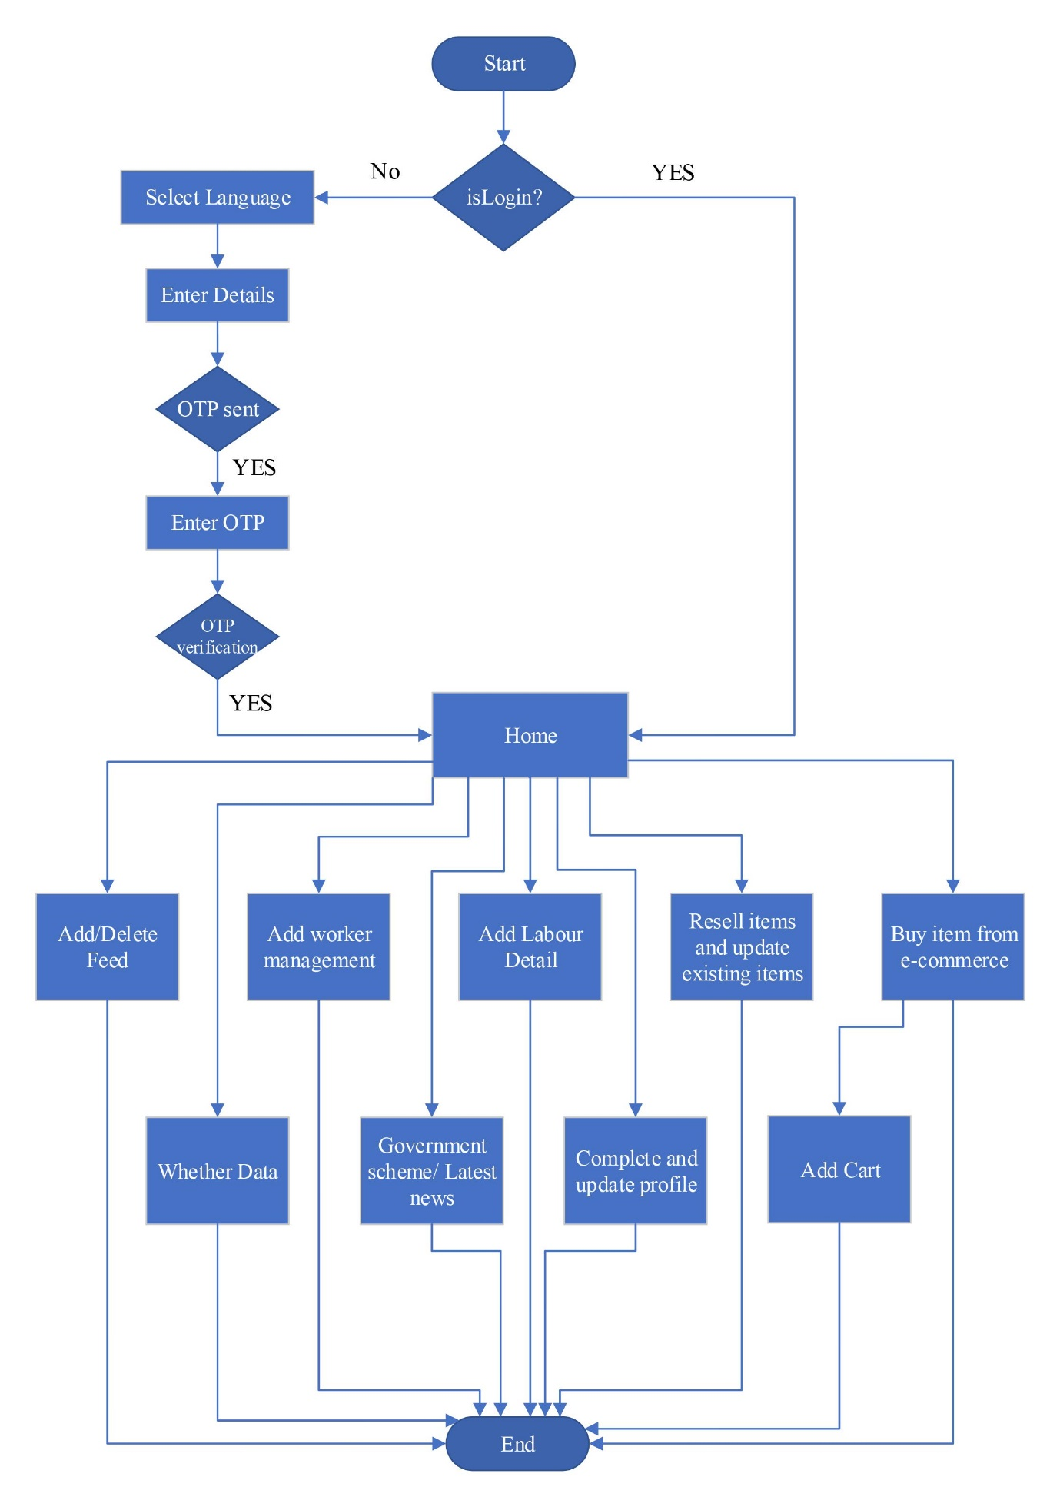

**4. DFD / UML Diagram**

**❖ 0 Level Diagram (Context Diagram):**

``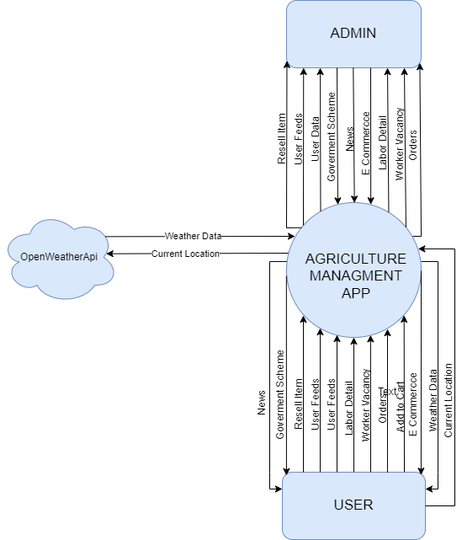

**❖ 1st Level Admin Diagram:**

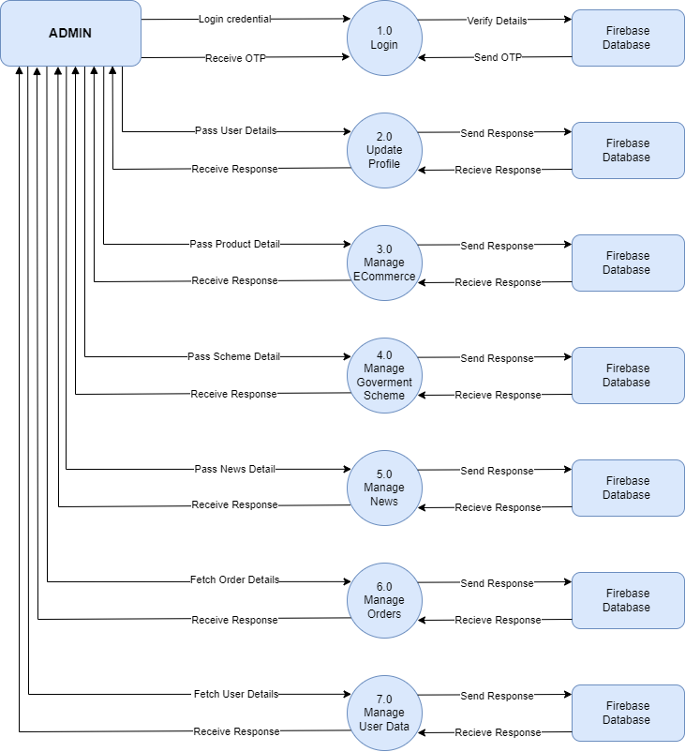

**❖ 1st Level User Diagram:**

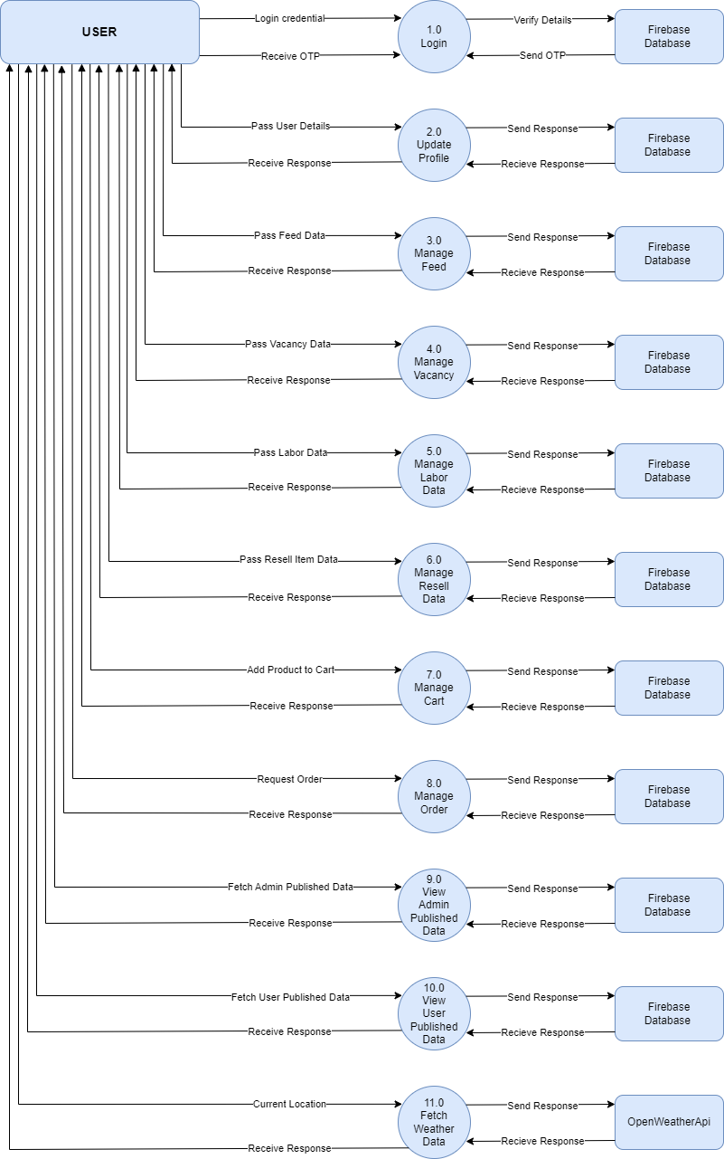

**5. ER Diagram**

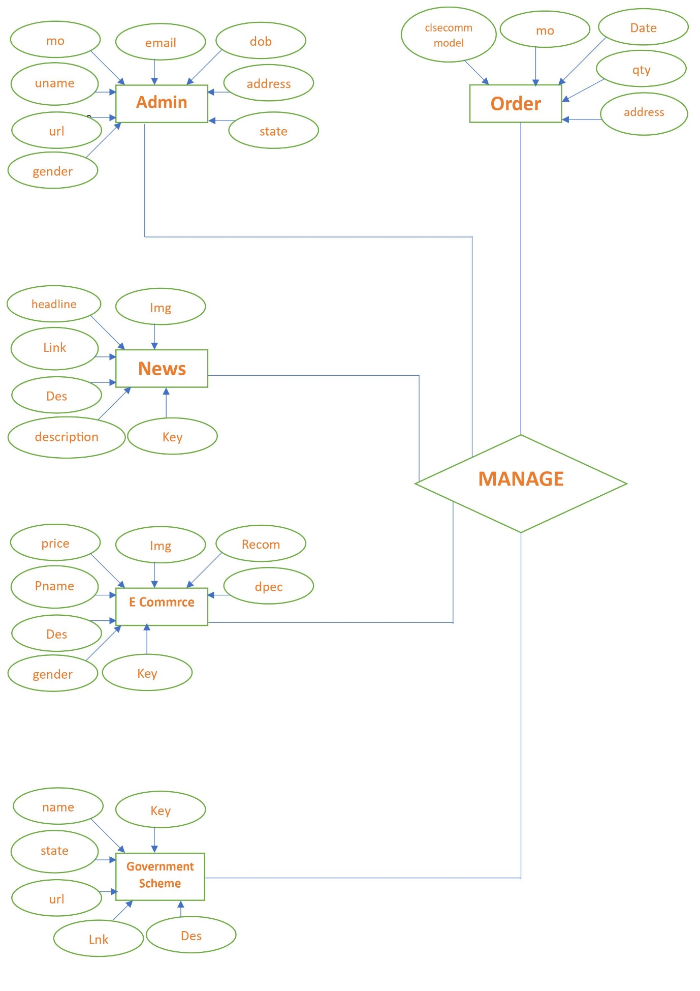

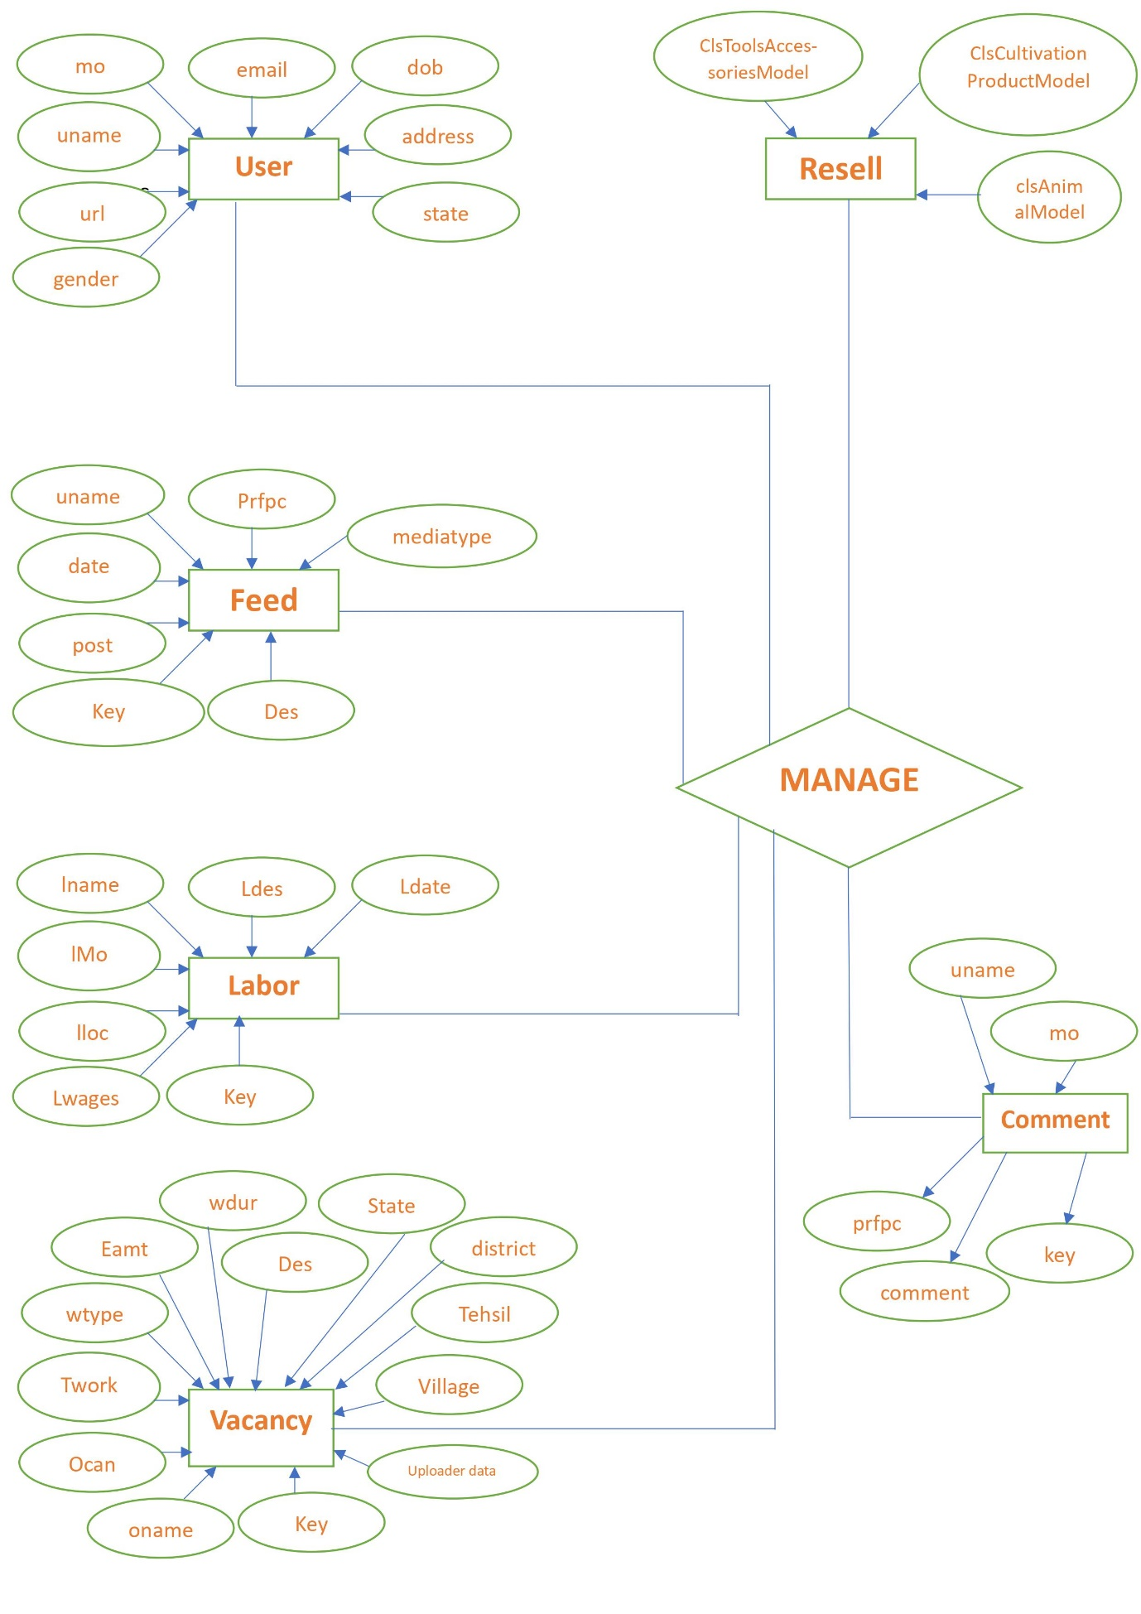

**6. Database Design**

**1.ClsUserModel**

|  |  |  |  |
| --- | --- | --- | --- |
| ClsUserModel | | | |
| No | Field Name | Data type | Description |
| 1 | uname | String | Username |
| 2 | mo | String | Mobile No. |
| 3 | url | String | Profile Picture URL |
| 4 | email | String | User Email |
| 5 | dob | String | Date Of Birth |
| 6 | gender | String | Gender |
| 7 | address | String | Address |
| 8 | state | String | State |

**2.ClsAnimalModel**

|  |  |  |  |
| --- | --- | --- | --- |
| ClsAnimalModel | | | |
| No | Field Name | Data type | Description |
| 1 | key | String | Unique key |
| 2 | type | String | Animal type |
| 3 | spiece | String | Spiece of Animal |
| 4 | ageyear | String | Animal Age year |
| 5 | agemonth | String | Animal Age month |
| 6 | mproduction | String | Production from Animal |
| 7 | weight | String | Weight of Animal |
| 8 | State | String | State of living |
| 9 | mo | String | Mobile number of owner |
| 10 | price | String | Price of Animal |
| 11 | district | String | District of living |
| 12 | tehsil | String | Tehsil of living |
| 13 | village | String | Village of living |
| 14 | des | String | Description about animal |
| 15 | Img | String | One Image of animal |
| 16 | uname | String | Username of uploader |
| 17 | Prfpc | String | Profile picture Url  of uploader |
| 18 | date | String | Date of Upload |
| 19 | Sname | String | Name of Seller |

**3.ClsCommentModel**

|  |  |  |  |
| --- | --- | --- | --- |
| ClsCommentModel | | | |
| No | Field Name | Data type | Description |
| 1 | uname | String | Username of Commenter |
| 2 | mo | String | Mobile No  of Commenter |
| 3 | prfpc | String | Profile Picture URL |
| 4 | comment | String | Comment text |
| 5 | key | String | Unique Key |

**4.ClscultivationProductionModel**

|  |  |  |  |
| --- | --- | --- | --- |
| ClscultivationProductionModel | | | |
| No | Field Name | Data type | Description |
| 1 | Key | String | Unique Key |
| 2 | category | String | Category of product |
| 3 | spiece | String | Spiece of product |
| 4 | pname | String | Product name |
| 5 | Qty | String | Quantity (In K.G.) |
| 6 | Price | String | Price (Per K.G.) |
| 7 | Payment | String | Total Payment |
| 8 | State | String | State of Origin |
| 9 | Mo | String | Mobile number of Seller |
| 10 | district | String | District of Origin |
| 11 | Tehsil | String | Tehsil of Origin |
| 12 | Village | String | Village of Origin |
| 13 | Des | String | Description of Product |
| 14 | Img | String | One Image of Product |
| 15 | uname | String | Username of Uploader |
| 16 | Prfpc | String | Profile picture url of Uploader |
| 17 | Date | String | Date of Upload |
| 18 | Sname | String | SellerName |

**5.ClsEcommModel**

|  |  |  |  |
| --- | --- | --- | --- |
| ClsEcommModel | | | |
| No | Field Name | Data type | Description |
| 1 | price | String | Price of product |
| 2 | Img | String | Image of Product |
| 3 | Recomm | String | Recommendation about Product |
| 4 | dpec | String | Specification of  Product |
| 5 | Key | String | Unique Key |
| 6 | Pname | String | Product name |
| 7 | Des | String | Description of Product |

**6.ClsFeedModel**

|  |  |  |  |
| --- | --- | --- | --- |
| ClsFeedModel | | | |
| No | Field Name | Data type | Description |
| 1 | Prfpc | String | Profile picture of  Uploader |
| 2 | uname | String | User name of  Uploader |
| 3 | date | String | Date of upload |
| 4 | post | String | Post (Image) |
| 5 | Key | String | Unique Key |
| 7 | Des | String | Description about post |
| 8 | mediatype | String | Media type  (description only,Image) |

**7.ClsGovModel**

|  |  |  |  |
| --- | --- | --- | --- |
| ClsGovModel | | | |
| No | Field Name | Data type | Description |
| 1 | name | String | Title of Scheme |
| 2 | state | String | Applicable State |
| 3 | url | String | URL of image |
| 4 | Des | String | Little Description About Scheme |
| 5 | Key | String | Unique Key |
| 6 | Lnk | String | URL of Official Website |

**8.ClsLaborModel**

|  |  |  |  |
| --- | --- | --- | --- |
| ClsLaborModel | | | |
| No | Field Name | Data type | Description |
| 1 | lname | String | Labor name |
| 2 | lMo | String | Labor Mobile No. |
| 3 | lloc | String | Labor location |
| 4 | Lwages | String | Labor wages |
| 5 | Key | String | Unique Key |
| 6 | Ldes | String | Description About Work |
| 7 | Ldate | String | Date of Work |

**9.ClsNewsModel**

|  |  |  |  |
| --- | --- | --- | --- |
| ClsNewsModel | | | |
| No | Field Name | Data type | Description |
| 1 | headline | String | Headline Of news |
| 2 | Link | String | Link to news-site |
| 3 | description | String | Description about news |
| 4 | Img | String | Tab Image of news |
| 5 | Key | String | Unique Key |

**10.ClsOrderModel**

|  |  |  |  |
| --- | --- | --- | --- |
| ClsOrderModel | | | |
| No | Field Name | Data type | Description |
| 1 | clsecommmodel | object | Object of product that is ordered |
| 2 | mo | String | Mobile no of Buyer |
| 3 | address | String | Delivery Address |
| 4 | qty | String | Ordered Quantity |
| 5 | Key | String | Unique Key |
| 6 | Date | String | Date of order |

**11. ClsToolsAccessoriesModel**

|  |  |  |  |
| --- | --- | --- | --- |
| ClsToolsAccessoriesModel | | | |
| No | Field Name | Data type | Description |
| 1 | Key | String | Key |
| 2 | category | String | Category of Product |
| 3 | pname | String | Product name |
| 4 | Price | String | Price of Product |
| 5 | month | String | Usage of Product in month |
| 6 | State | String | State of Origin |
| 7 | Mo | String | Mobile number Of seller |
| 8 | district | String | District of Origin |
| 9 | Tehsil | String | Tehsil of Origin |
| 10 | Village | String | Village of Origin |
| 11 | Des | String | Description About Product |
| 12 | Img | String | Image Of product |
| 13 | uname | String | Username Of uploader |
| 14 | Prfpc | String | Profile picture of  Uploader |
| 15 | Date | String | Date Of Upload |
| 16 | Sname | String | Seller Name |

**12. ClsVacancyModel**

|  |  |  |  |
| --- | --- | --- | --- |
| ClsVacancyModel | | | |
| No | Field Name | Data type | Description |
| 1 | Key | String | Unique Key |
| 2 | oname | String | Name of Recruiter (Owner) |
| 3 | Ocan | String | Owner Contact Number |
| 4 | Twork | String | Type of work |
| 5 | wtype | String | Wage type  (Fix, Partnership) |
| 6 | Eamt | String | Expected Earning amount |
| 7 | wdur | String | Work duration |
| 8 | district | String | District of Origin |
| 9 | Tehsil | String | Tehsil of Origin |
| 10 | Village | String | Village of Origin |
| 11 | Des | String | Description about work to do |
| 12 | State | String | State of Origin |
| 13 | uname | String | Username of Publisher |
| 14 | Prfpc | String | Profile picture of Publisher |
| 15 | Date | String | Publish Date |

**7.File Listing**

|  |  |
| --- | --- |
| **Java File Name** | **Corresponding Xml File** |
| add_animal | activity_add_animal.xml |
| add_cultivation_product | activity_add_cultivation_product.xml |
| add_ecomm | activity_add_ecomm.xml |
| add_feed | activity_add_feed.xml |
| add_gov_scheme | activity_add_gov_scheme.xml |
| add_labour | activity_add_labour.xml |
| add_labour_vacancy | activity_add_labour_vacancy.xml |
| add_news | activity_add_news.xml |
| add_tools_accesories | activity_add_tools_accesories.xml |
| add_tools_categories | activity_add_tools_categories.xml |
| add_video | activity_add_video.xml |
| admin_animal | activity_admin_animal.xml |
| admin_cultivation | activity_admin_cultivation.xml |
| admin_ecom | activity_admin_ecom.xml |
| admin_home | activity_admin_home.xml |
| admin_resell_category | activity_admin_resell_category.xml |
| admin_tools | activity_admin_tools.xml |
| animal_category_Activity | activity_animal_category.xml |
| animals | fragment_animals.xml |
| Cart | activity_cart.xml |
| category_cultivation | activity_category_cultivation.xml |
| clsAnimalModel | none |
| clsCommentModel | none |
| ClsCultivationProductModel | none |
| clsEcommModel | none |
| clsFeedModel | none |
| clsgovmodel | none |
| clsLaborModel | none |
| clsLikemodel | none |
| clsNewsModel | none |
| clsOrderModel | none |
| clsToolsAccessoriesModel | none |
| clsUserModel | none |
| clsVacancyModel | none |
| Contact_us | activity_contact_us.xml |
| Cultivation_Product | fragment_cultivation__product.xml |
| E_commrce | fragment_e_commrce.xml |
| EditprofileActivity | fragment_e_commrce.xml |
| Feed | fragment_feed.xml |
| frghome | fragment_frghome.xml |
| govermentScheme | activity_goverment_scheme.xml |
| Home | activity_home.xml |
| **Java File Name** | **Corresponding Xml File** |
| Labour | fragment_labour.xml |
| Labour_Management | fragment_labour__management.xml |
| Labour_Vacancy | fragment_labour__vacancy.xml |
| Language | activity_language.xml |
| MainActivity | activity_main.xml |
| Myfeed | fragment_myfeed.xml |
| MyOrder | activity_my_order.xml |
| MyProducts | fragment_my_products.xml |
| MyVacancy | fragment_my_vacancy.xml |
| Navigation | activity_navigation.xml |
| news | activity_news.xml |
| orderbydate | activity_orderbydate.xml |
| Other_vacancy | fragment_other_vacancy.xml |
| OTP | activity_otp.xml |
| RcAnimalAdapter | none |
| RccommentAdapter | none |
| RcCultivatonPrdtAdpter | none |
| RcEcommAdapter | none |
| RcFeedAdapter | none |
| RcGovAdapter | none |
| RcLabourAdapter | none |
| RcnewsAdapter | none |
| RcorderAdapter | none |
| RcToolsAccesoriesAdapter | none |
| RcuserAdapter | none |
| RcVacancyAdapter | none |
| Resell | fragment_resell.xml |
| Resell_Category | activity_resell_category.xml |
| show_CultivationProduct | activity_show_cultivation_product.xml |
| show_ecom_prdt | activity_show_ecom_prdt.xml |
| ShowFeed | fragment_show_feed.xml |
| splashActivity | activity_splash.xml |
| Term_Conditions | activity_term_conditions.xml |
| toos_accesories | fragment_toos_accesories.xml |
| User_list | activity_user_list.xml |
| User_option | activity_user_option.xml |
| User_output | activity_user_output.xml |
| VpAdapterFeed | none |
| VpAdapterLabour | none |
| VpAdapterResell | none |
| VpVacancyAdapter | none |
| Write_share | activity_write_share.xml |
| none | lytaddfeed.xml |
| none | lytanimalsheet.xml |
| none | lytbtmtools.xml |
| **Java File Name** | **Corresponding Xml File** |
| none | lytcomments.xml |
| none | lytcprdt.xml |
| none | lytdelete.xml |
| none | lytecom.xml |
| none | lyteditoption.xml |
| none | lytfeed.xml |
| none | lytgov.xml |
| none | lytlabor.xml |
| none | lytlbrvacancy.xml |
| none | lytloading.xml |
| none | lytnews.xml |
| none | lytordersheet.xml |
| none | lytrccmt.xml |
| none | lyttoast.xml |
| none | lyttoastgreen.xml |

* Apart from these files 10 String Files, Theme Files and Hundreds of Drawable and other Resources files are used.

**8.System Design**

* + **Splash Screen**



* **Select Language**

User Have to Choose Any One Language in Which UI Of Application will Be Available. However, Language Can also Changed Inside Application.

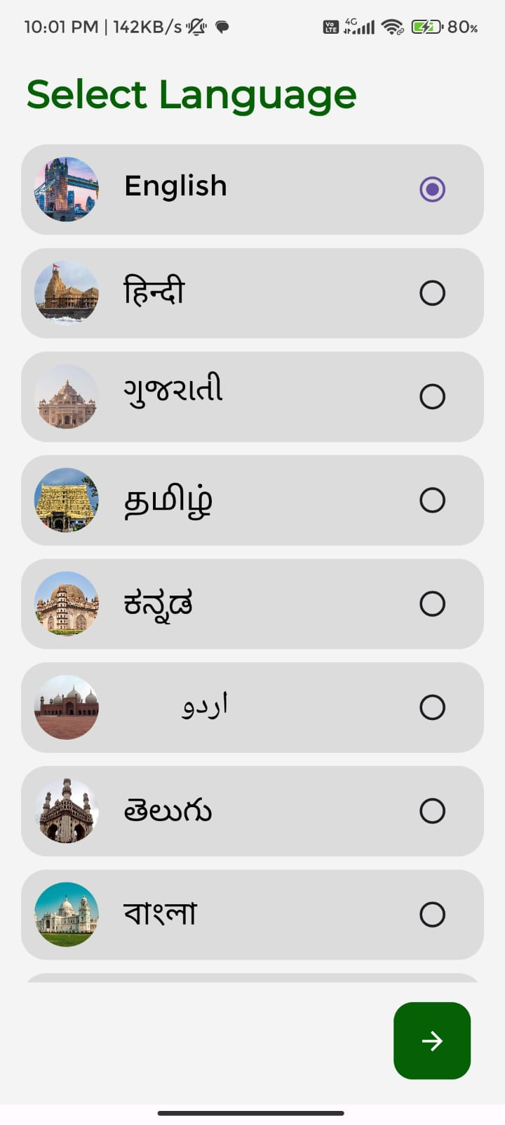 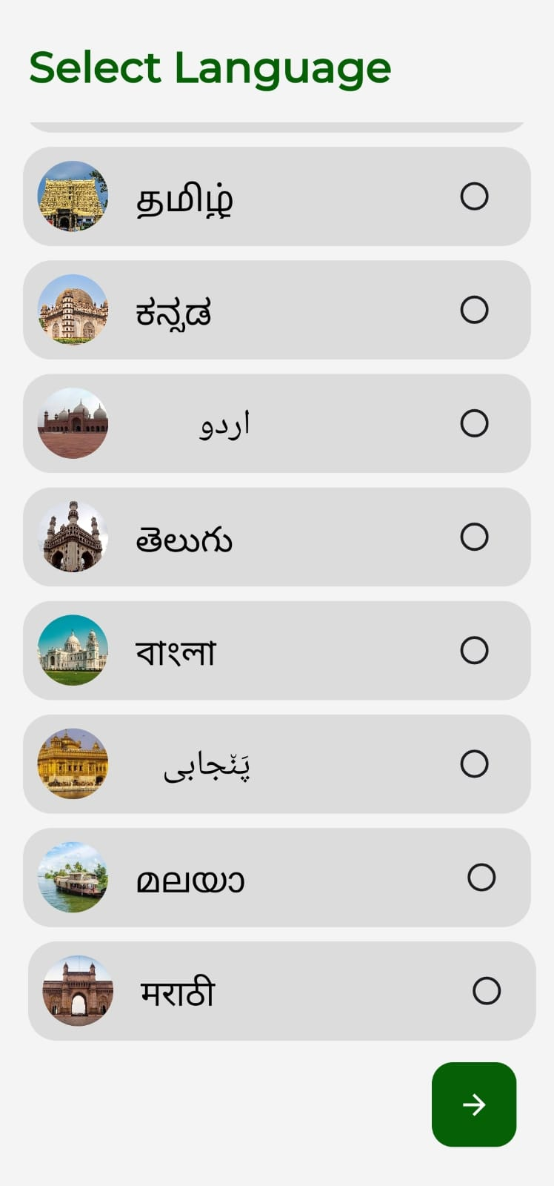

* + **Authentication**

User Have to Authenticate Their Mobile No. By Providing 6 Digits OTP sent to their entered mobile number. Moreover, a Proper Authentication Have set up so there are minimal chances of fake credential login.

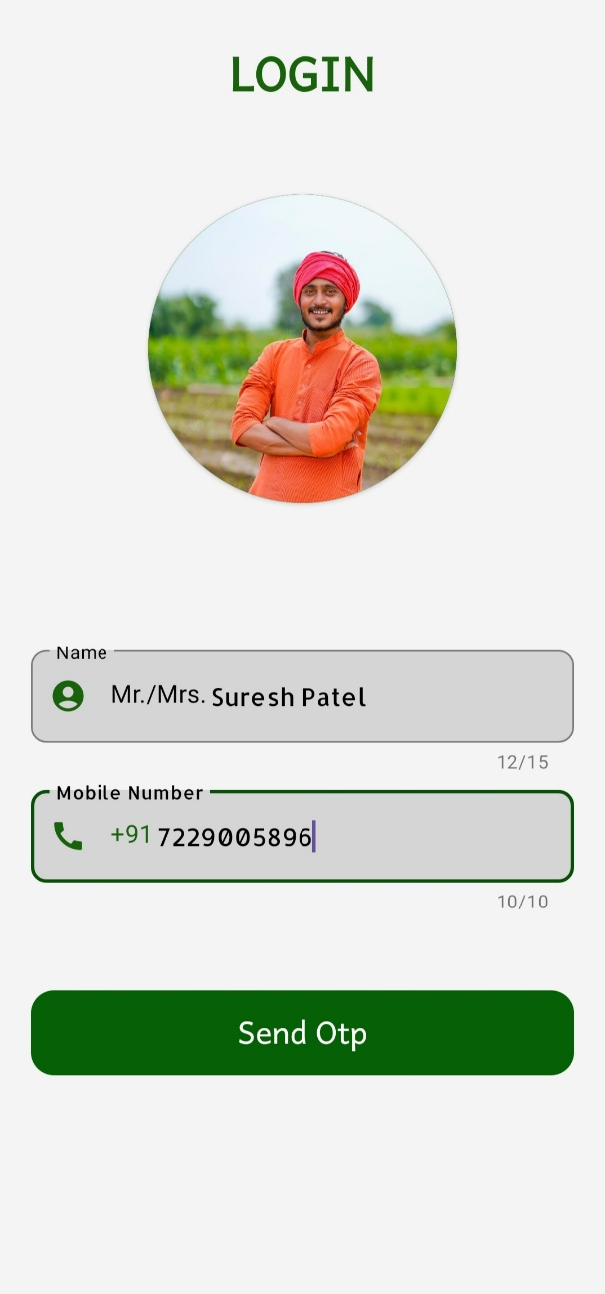 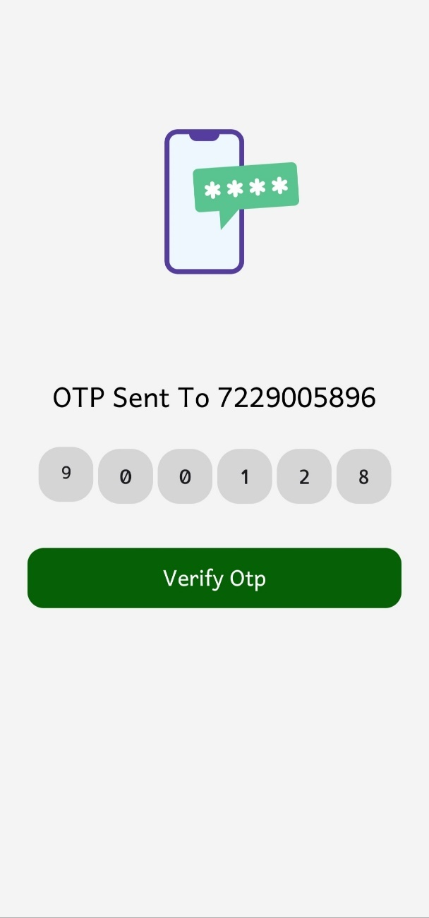

* **Home screen**

User who has successfully passed login detail will be redirected to home screen (feed section). However, we will start with home dashboard which contains weather data fetched from OpenweatherApi also Latest news and Notifications related to farmer community. Moreover, You Can redirect to Navigation Activity by Clicking on Profile Picture also to Cart and Order History by respective Icon.

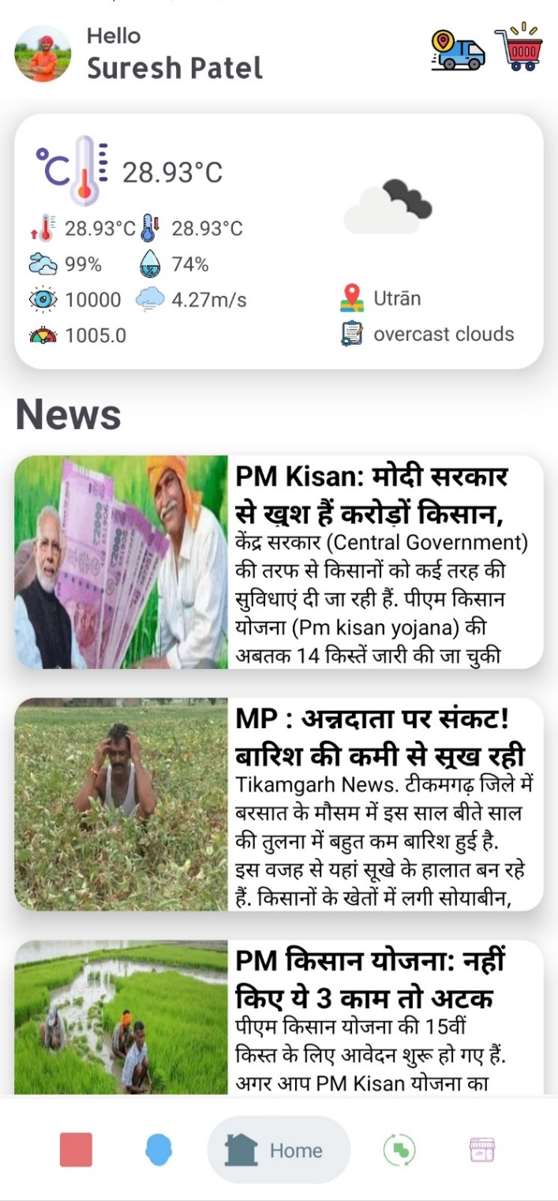

* **Feed**

User can their network by our feed module. User may add Photo, description as well as publish articles. Which can be seen by other logged in user who can response by liking, commenting and sharing the feed. User is allowed to remove his own feed, comment, like.

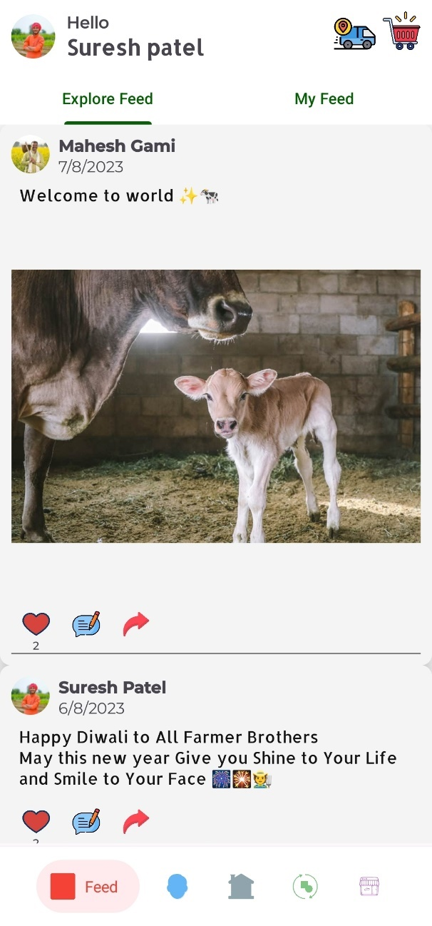 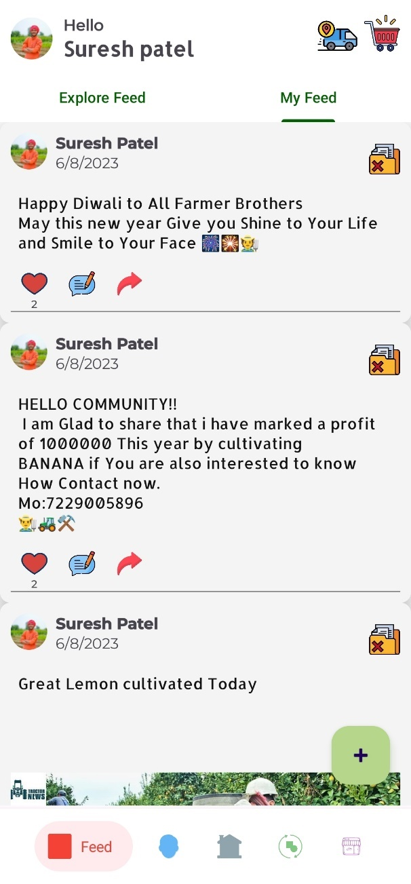

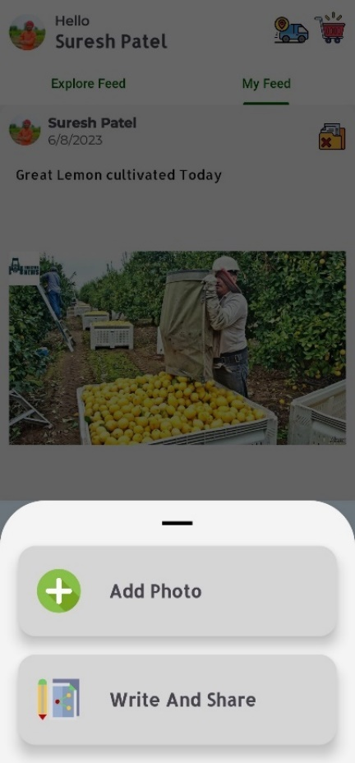 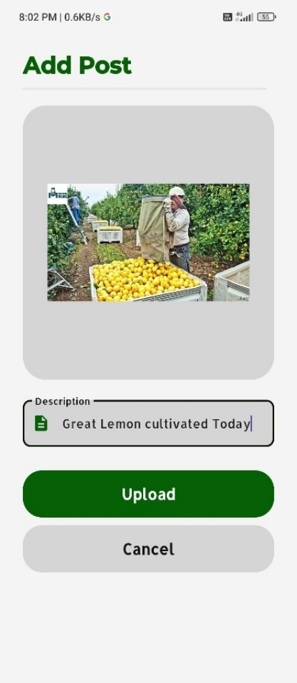 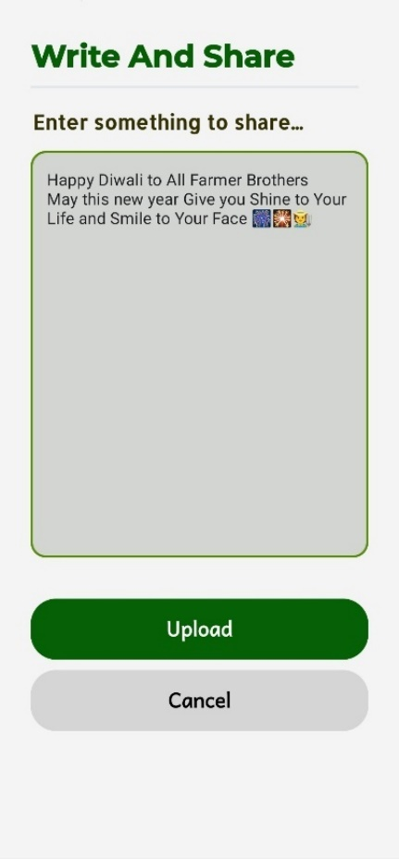

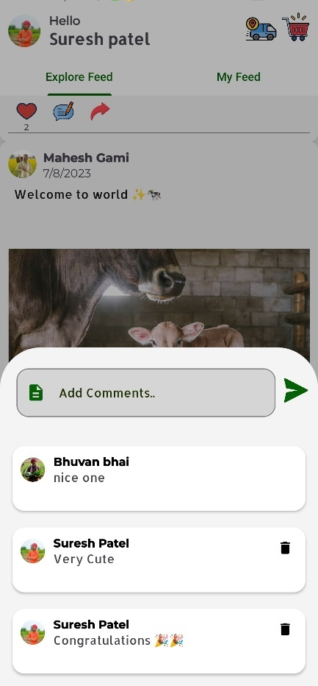 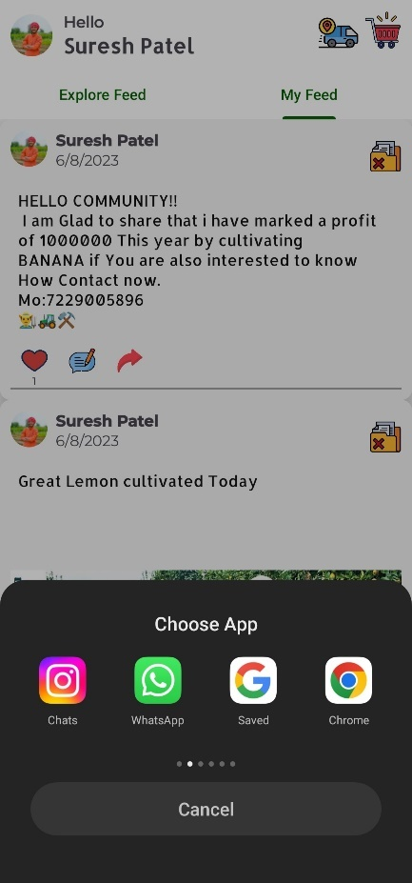 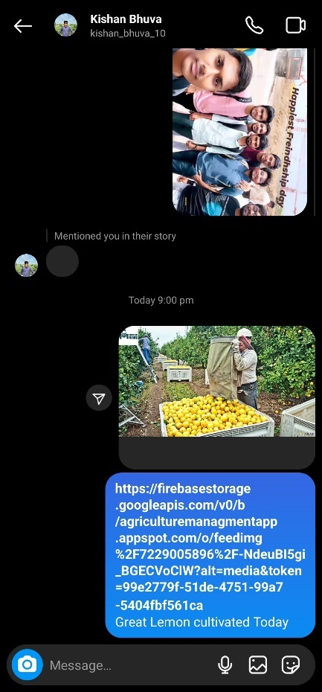

* **Vacancy**

Farmers who do farming on large scale may want to find worker. Our app makes it easy as we provide facility to publish vacancy, Worker on our app will see job definition and contact labourer if they are interested by call, WhatsApp message.

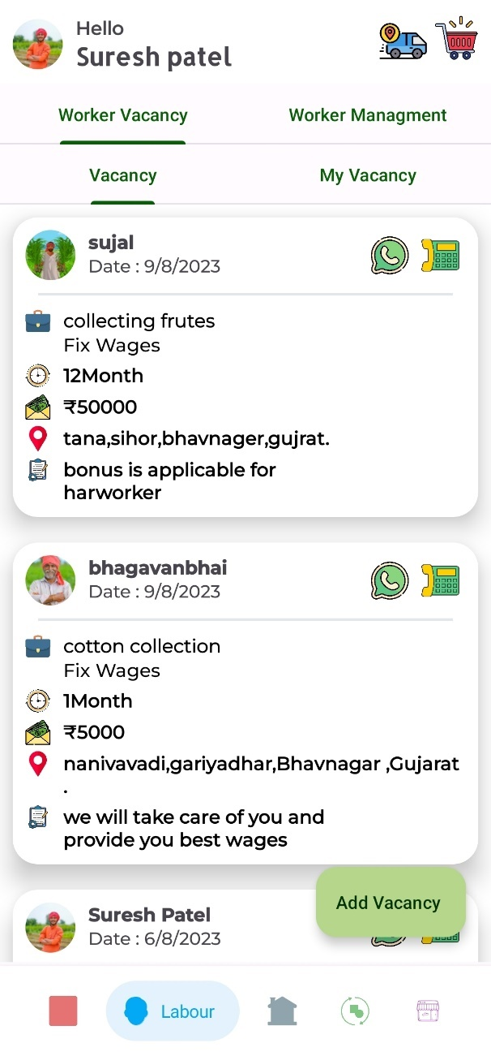 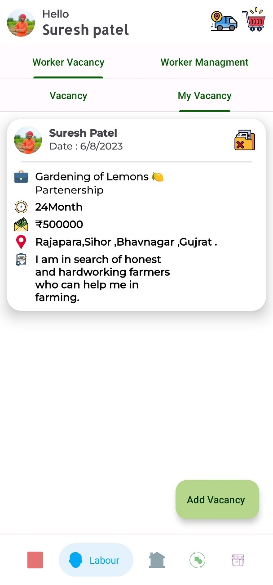

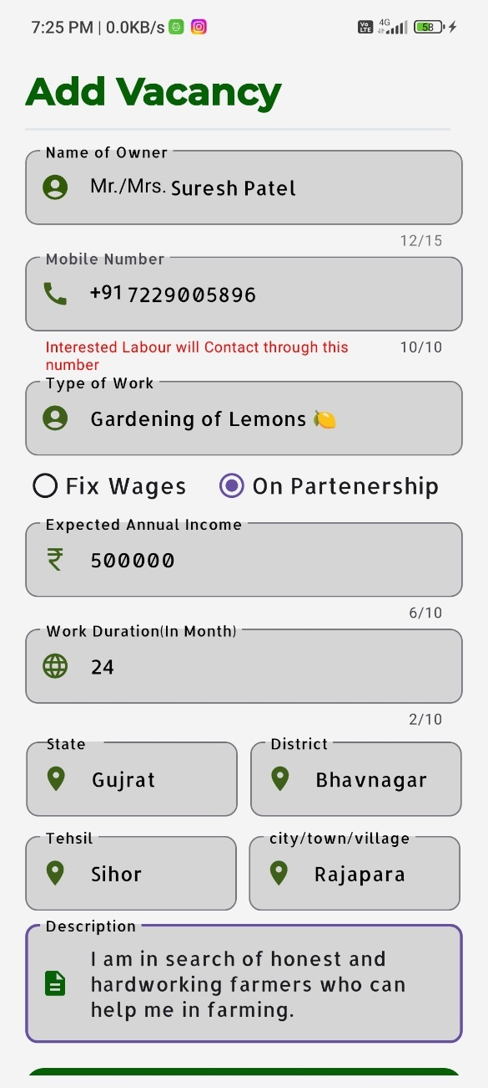 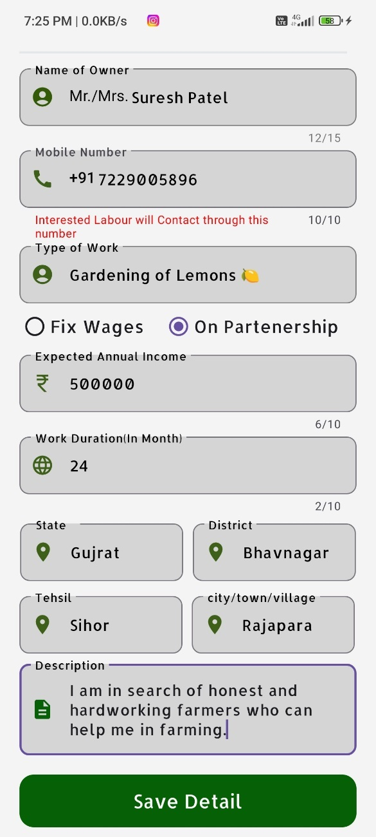

* **Wages / Worker Management**

Traditionally, Farmers have to make daily record of each farmer wages and also give a confirmation receipt to worker. But now with our app we make this entire process digital. Wages details will reside in farmers account on the other hand on SMS is sent to specified worker ‘s Mobile no which also eliminate the need of smart phone for worker.

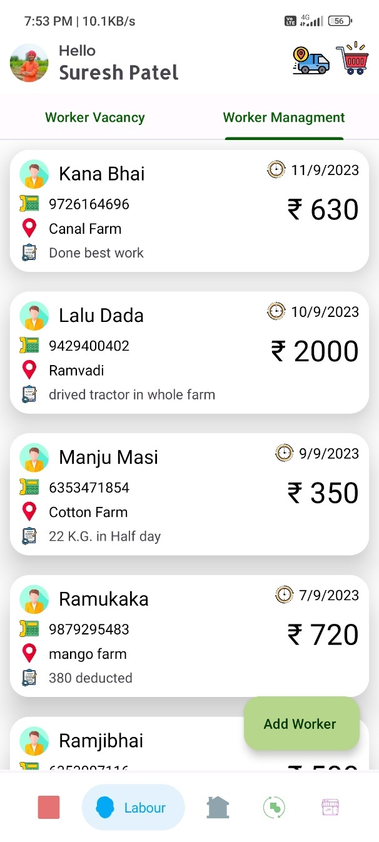

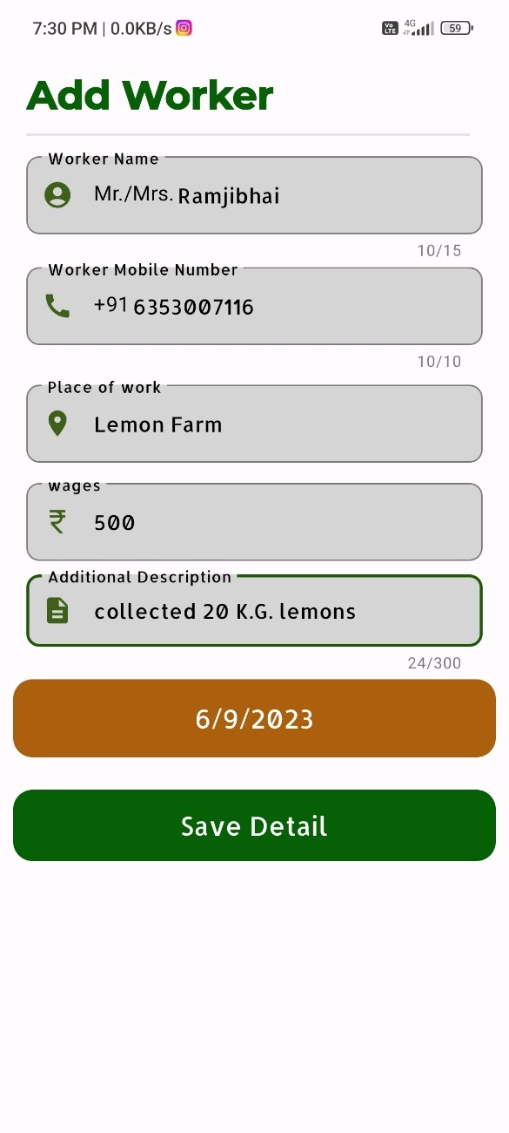 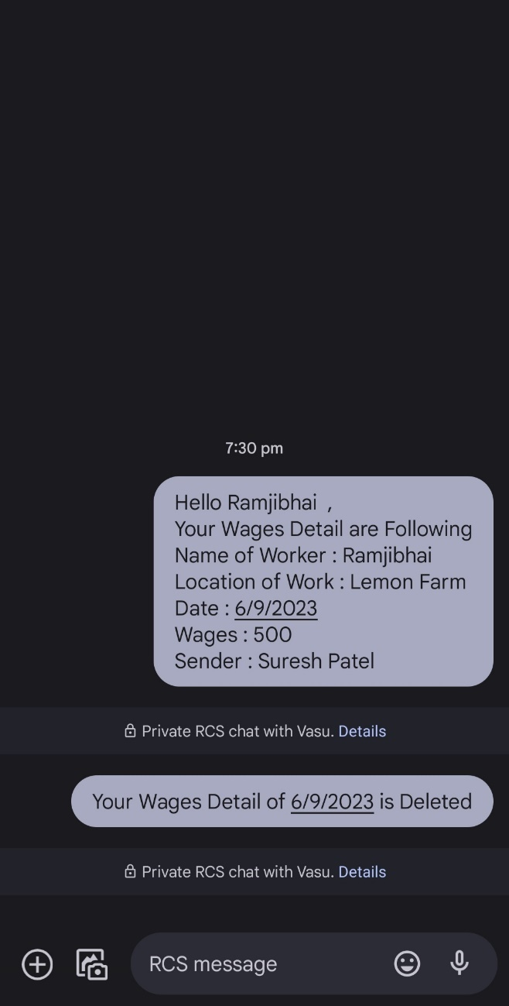

A deletion message is also sent if labourer delete wages detail of farmer.

* **Resell**

Farmers may want to sell their farming tools,equipment,vehicles after certain usage whereas many want to buy them for lower cost compare to new one.

Secondly, a direct business of cultivation product from farmer to seller will benefits both farmers as well as seller.

Likewise, Domestic Animal is also a huge part of farming activity farmers buy and sell them very often.

Our app combines all these features.

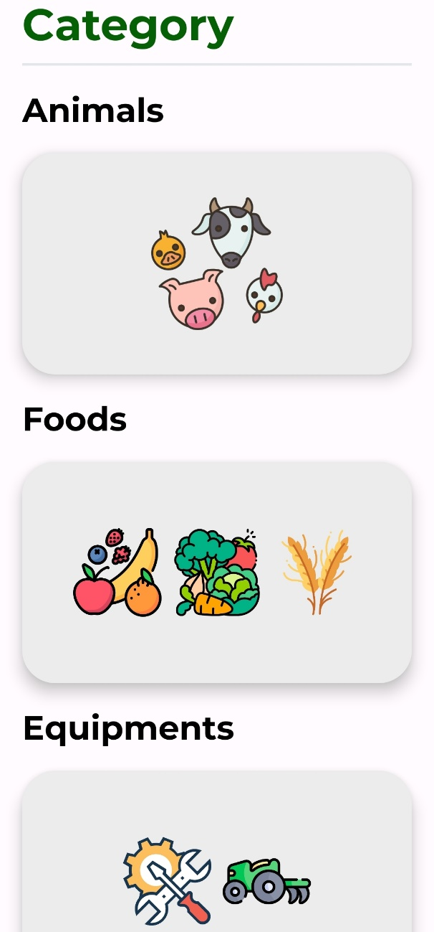

* **Animals**

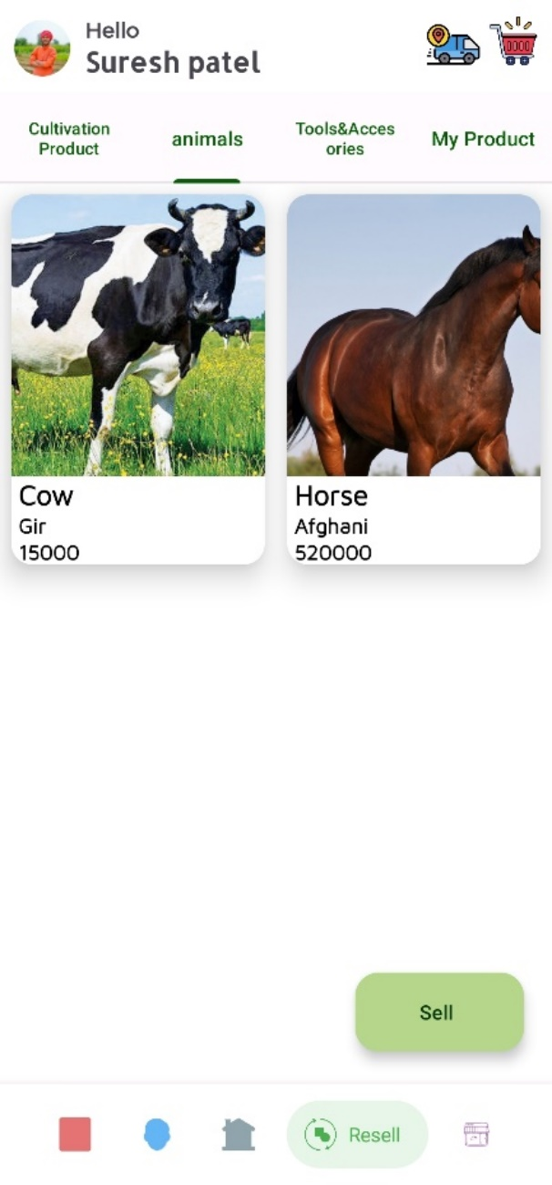 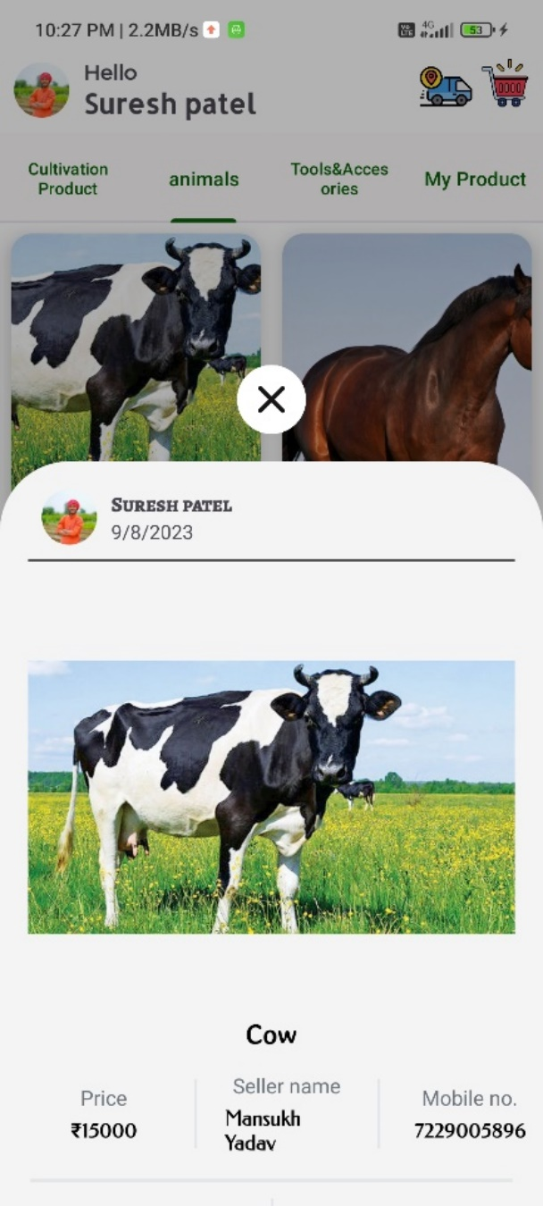

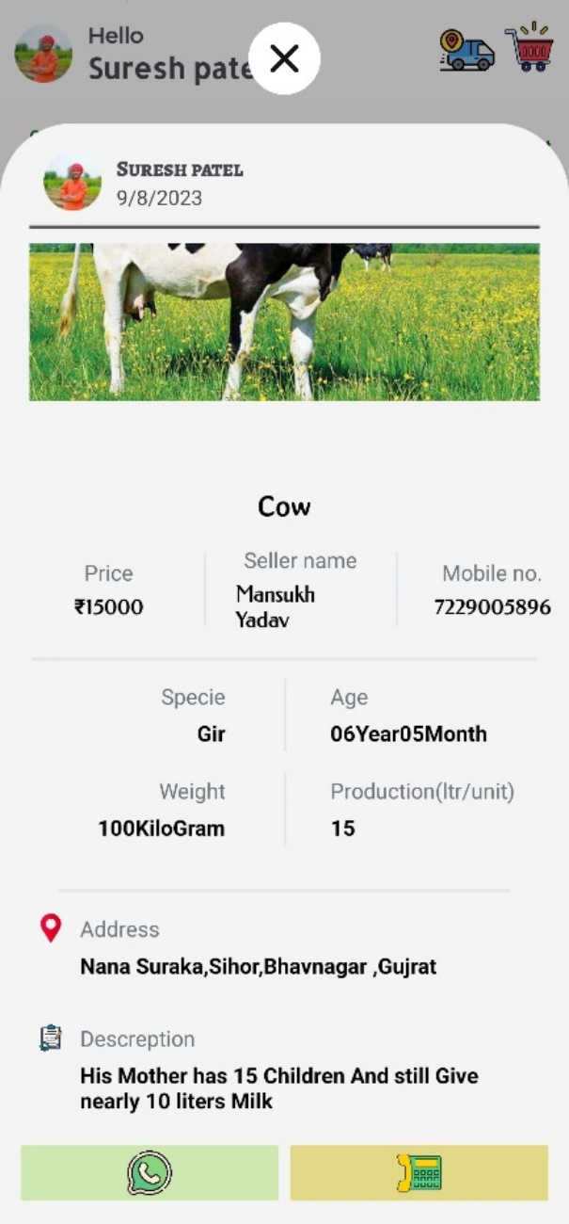 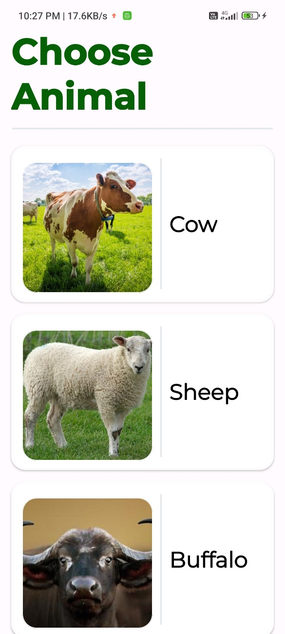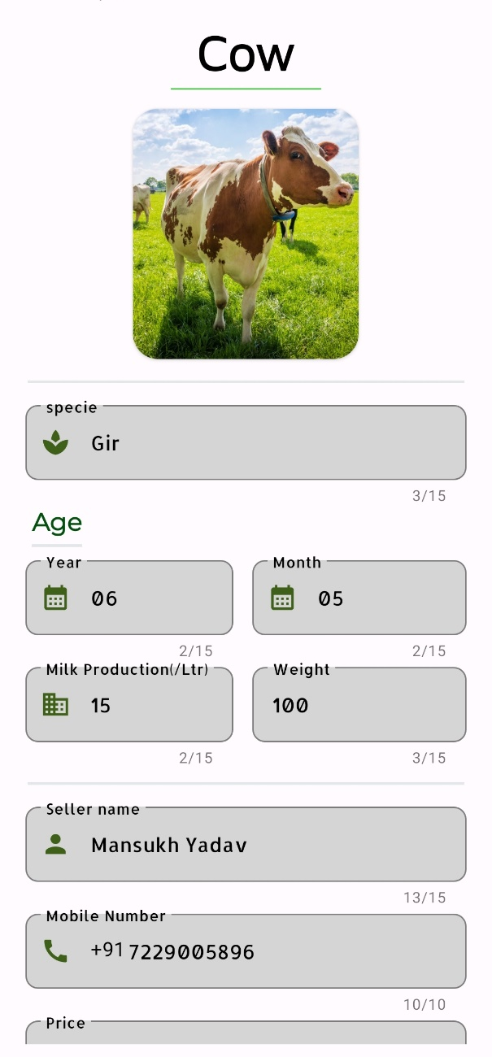 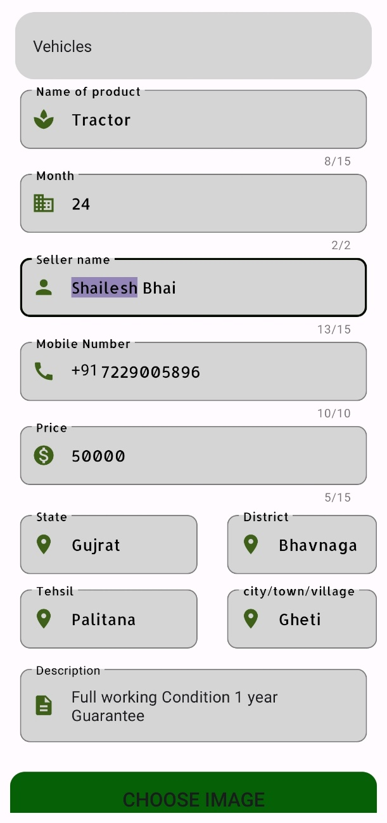

* **Cultivation Product**

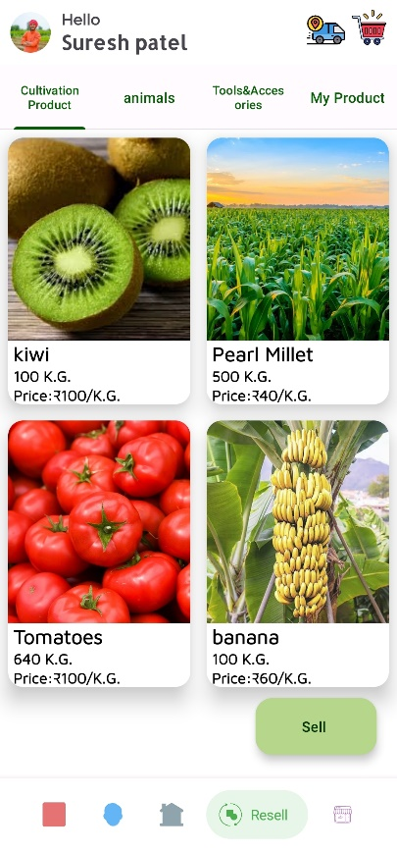 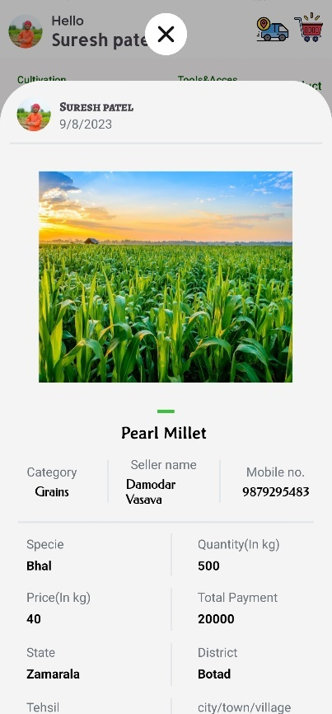 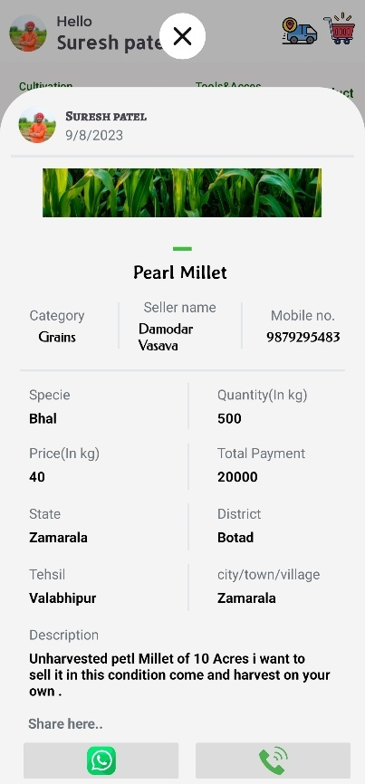

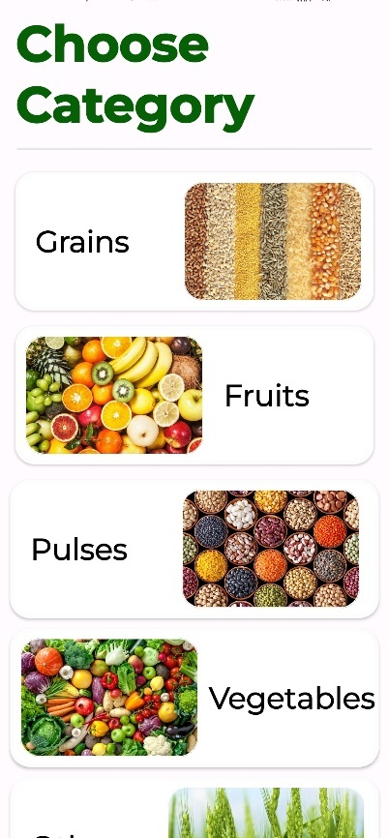 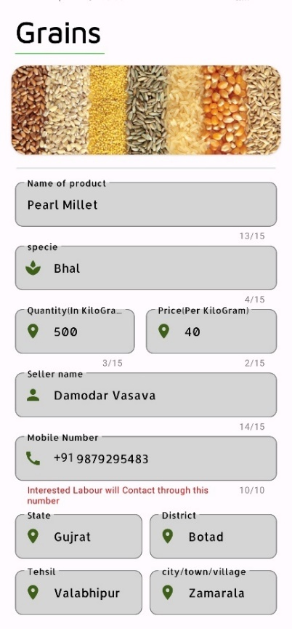 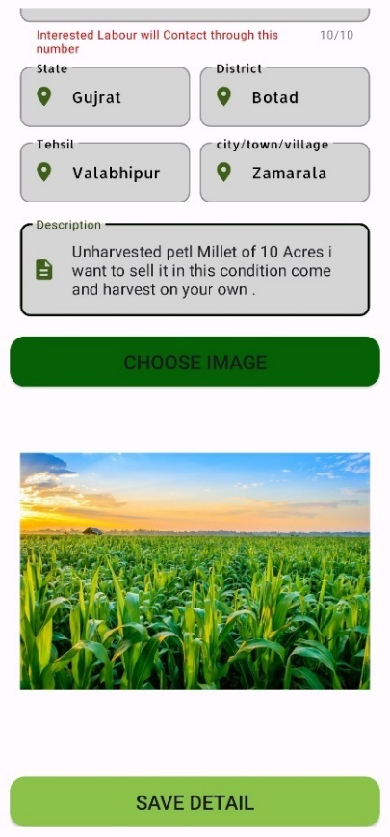

* **Tools & Accessories**

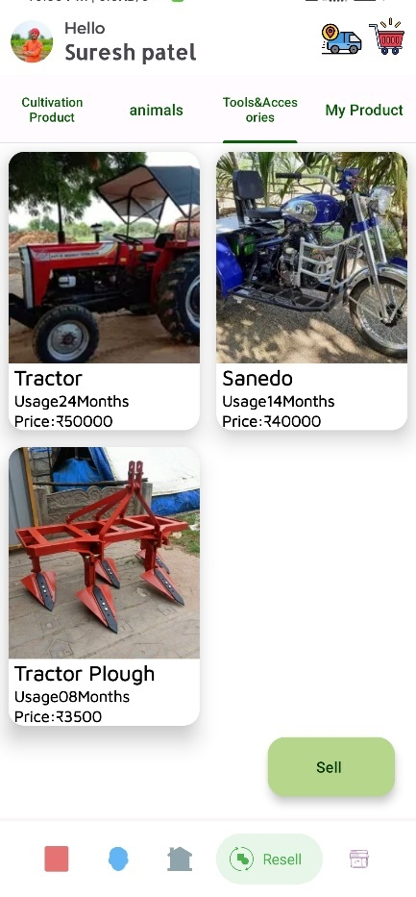 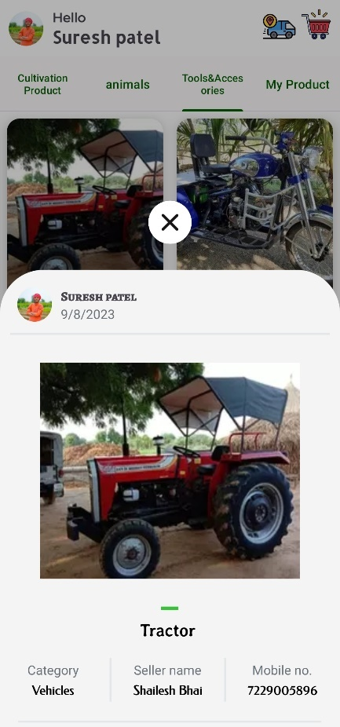 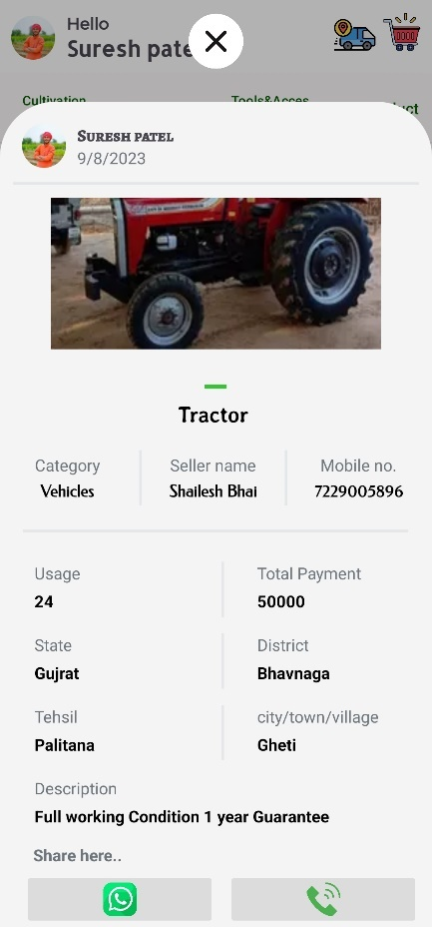

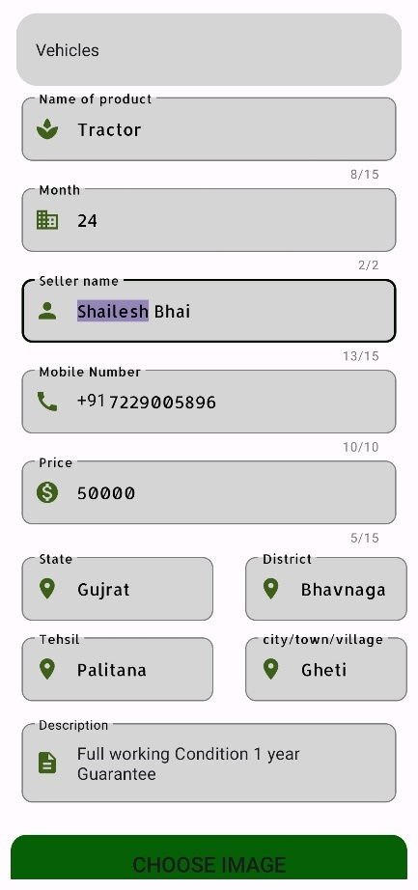 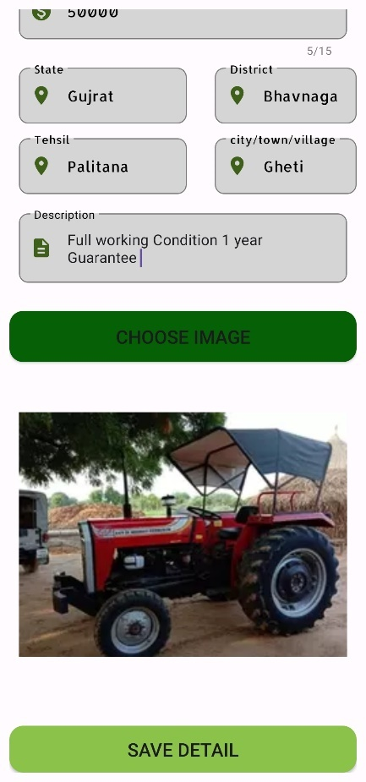

* **My Products**

Here, User may see their Uploaded Product and have rights to update them as well as delete them.

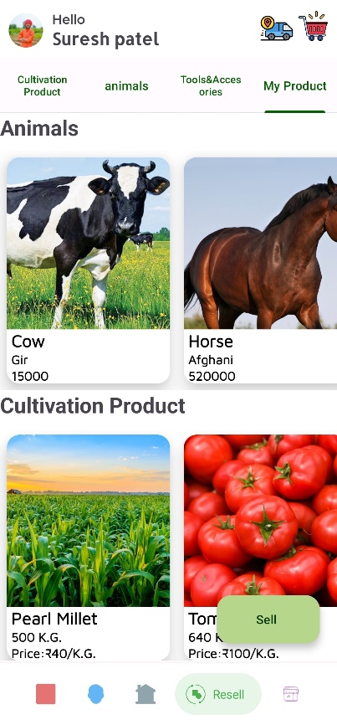 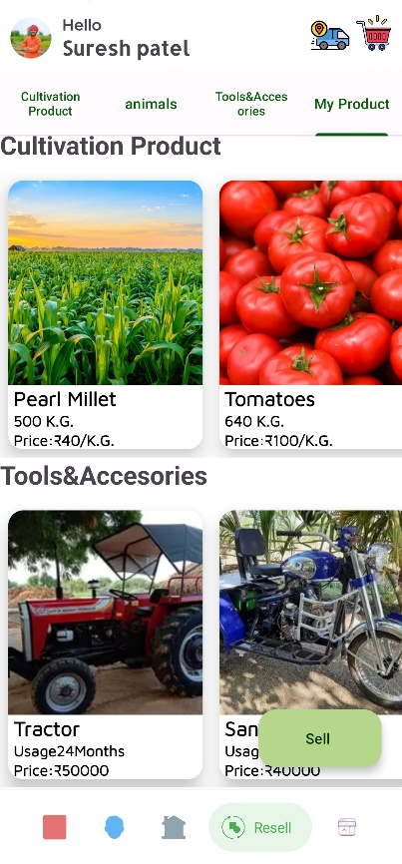 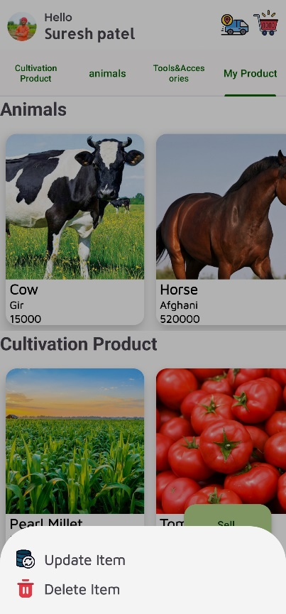

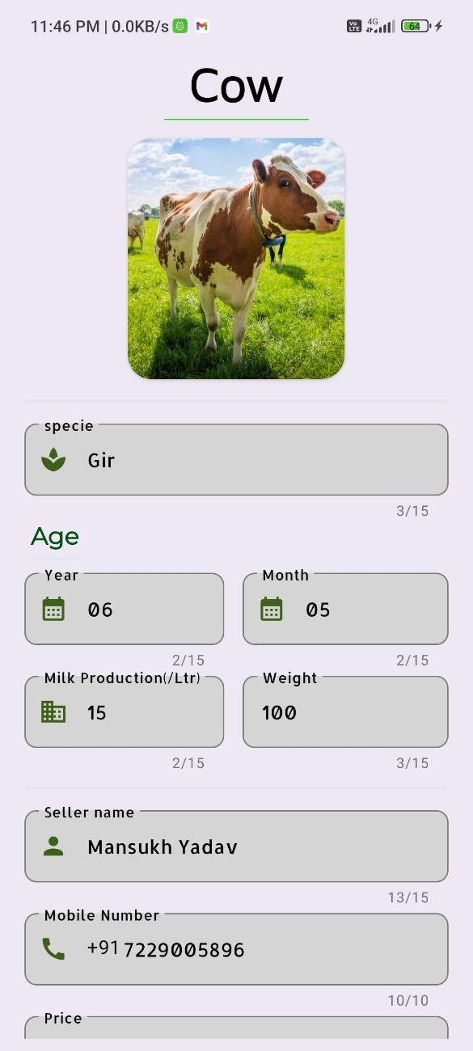 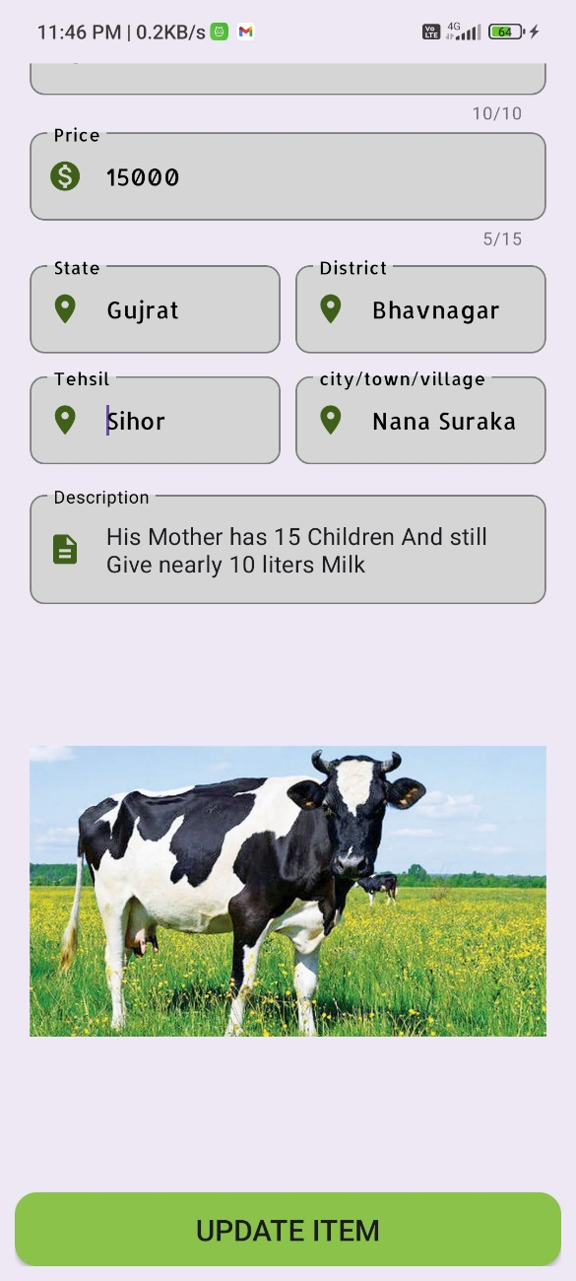

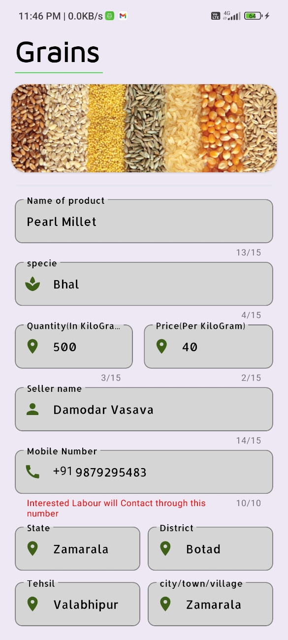 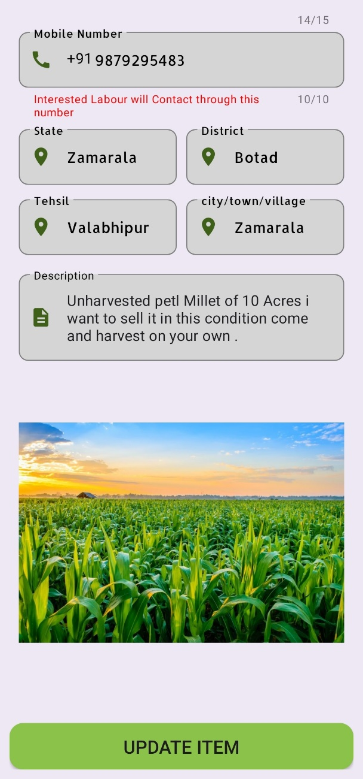

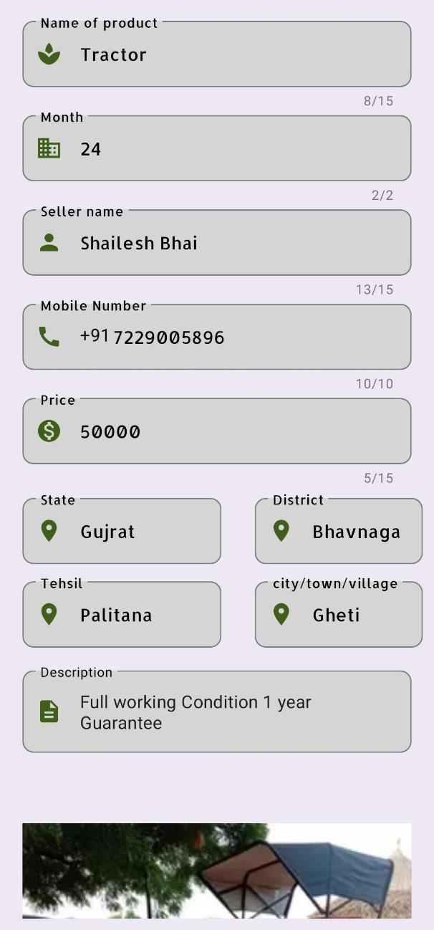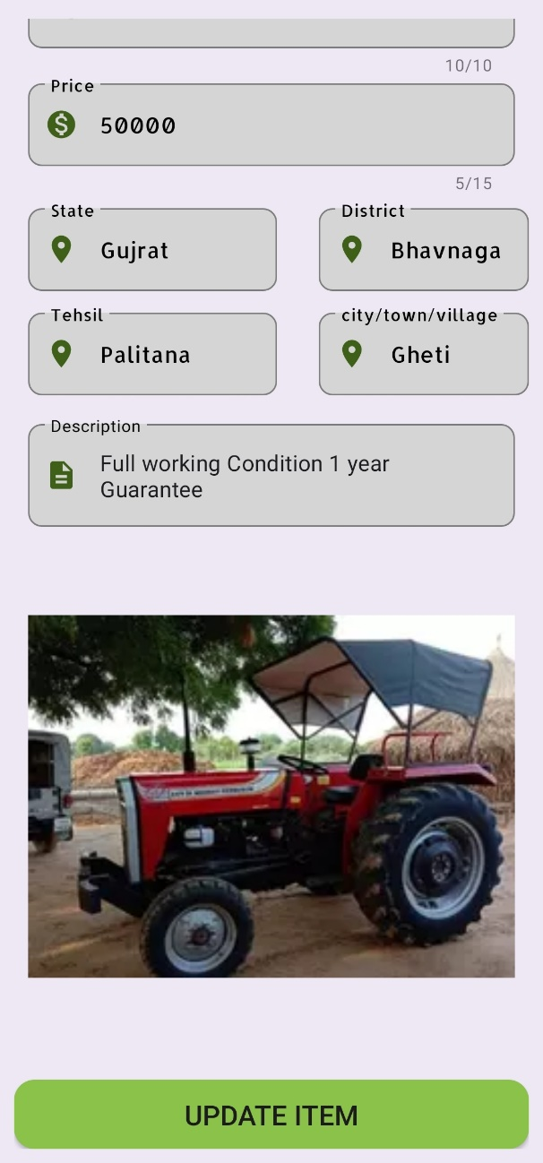

* **E Commerce**

We also provide facility to fulfil agriculture need and deliver them to your door steps. our Ecommerce store facilitates farmer to buy product of their need any time anywhere. We have very simple e commerce module that supports COD mode for payment.

* **View Product**

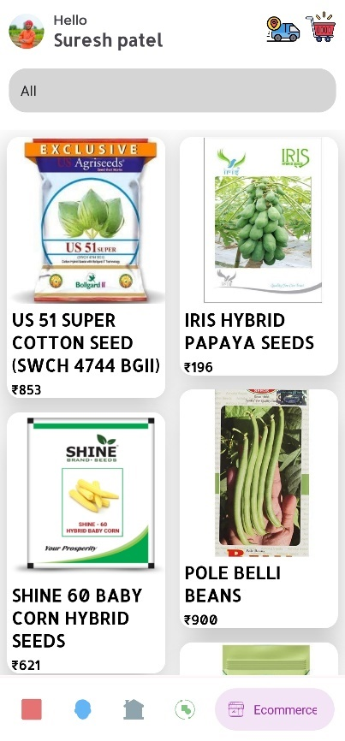 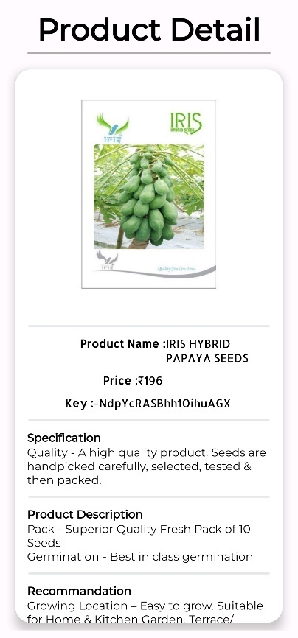 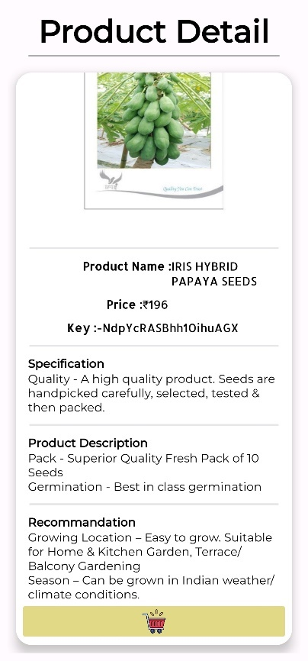

* **Cart**

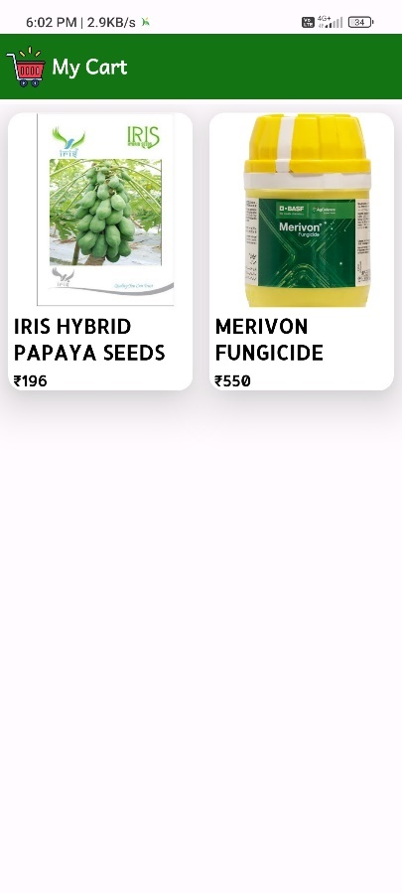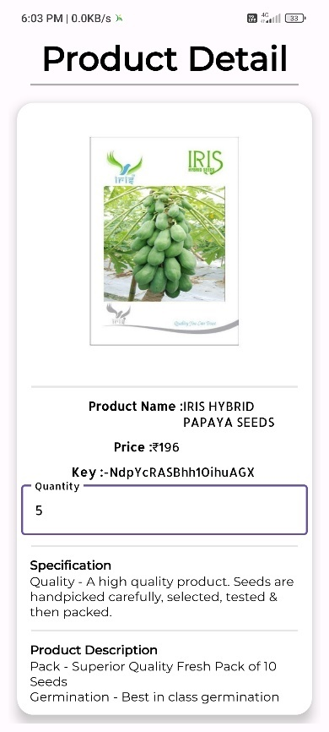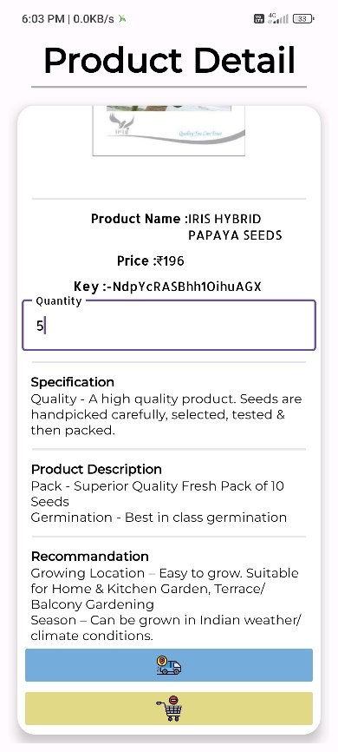

* **My Order**

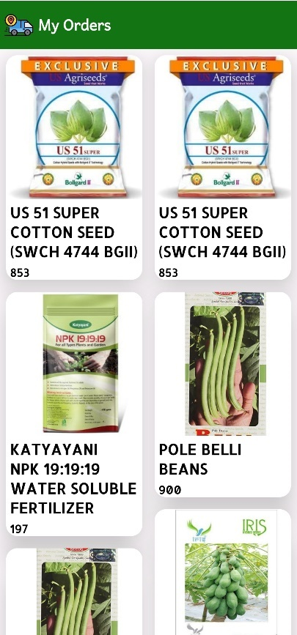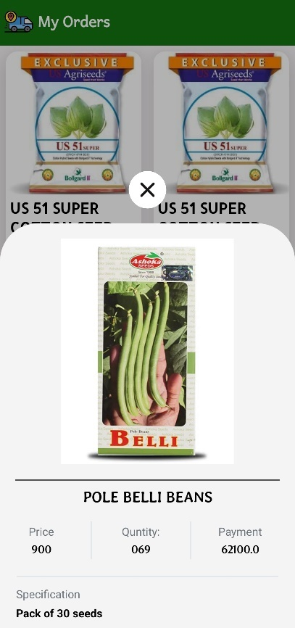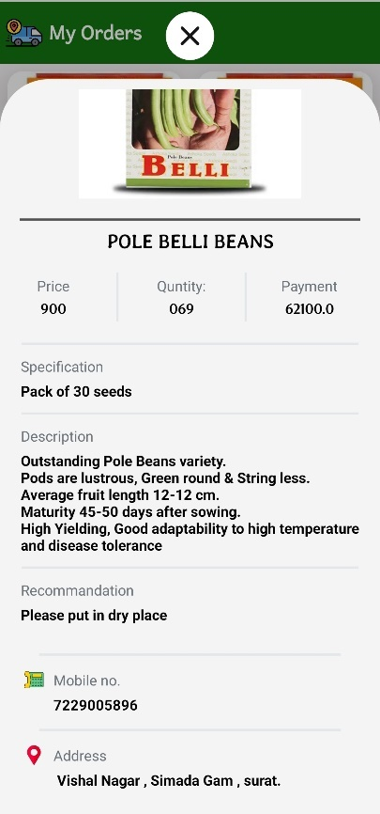

* **Navigation**

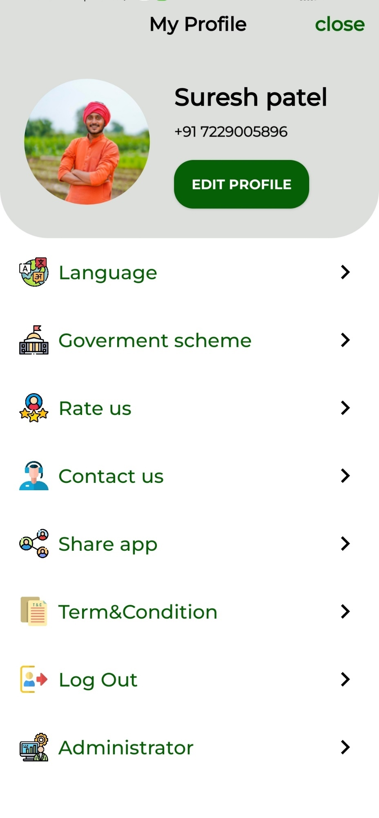

* **EditProfile**

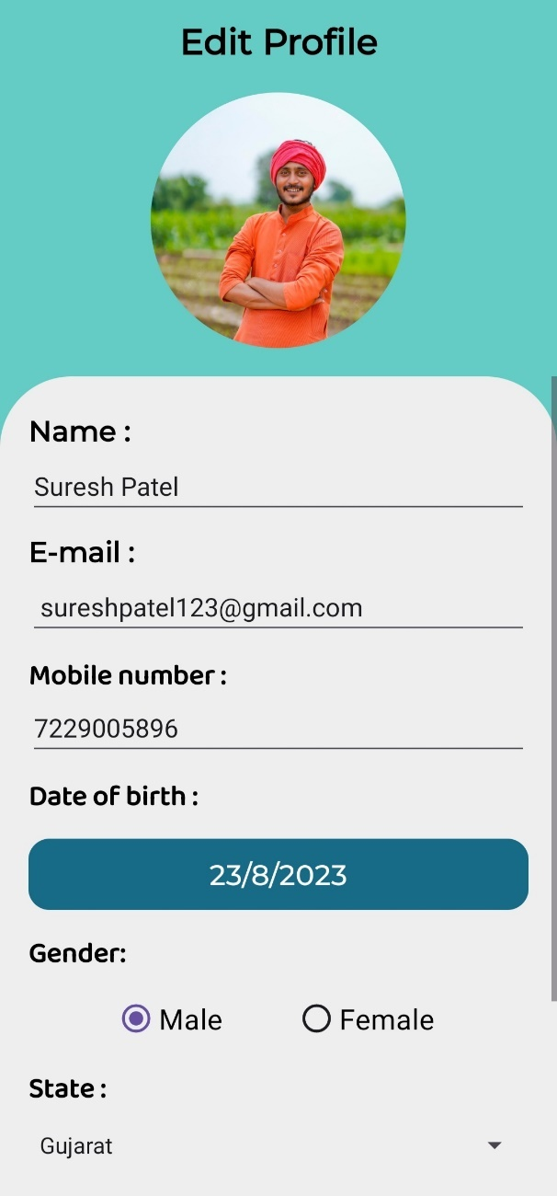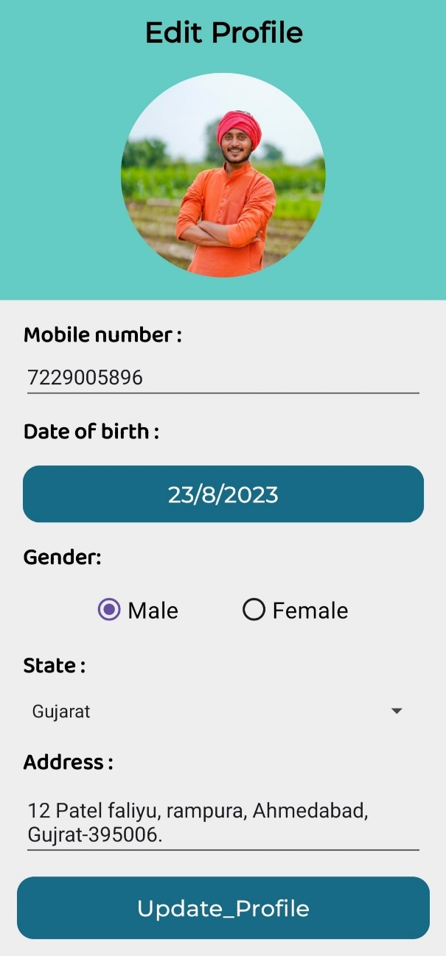

* **Government Scheme**

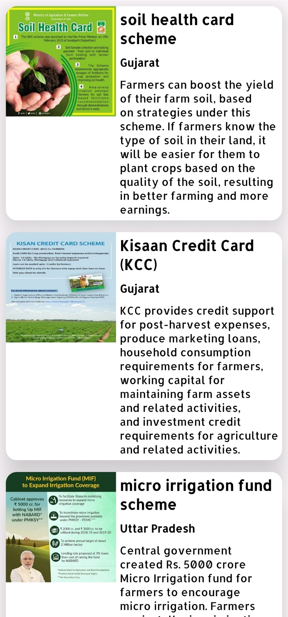

* **Contact us**



* **Terms & Condition**

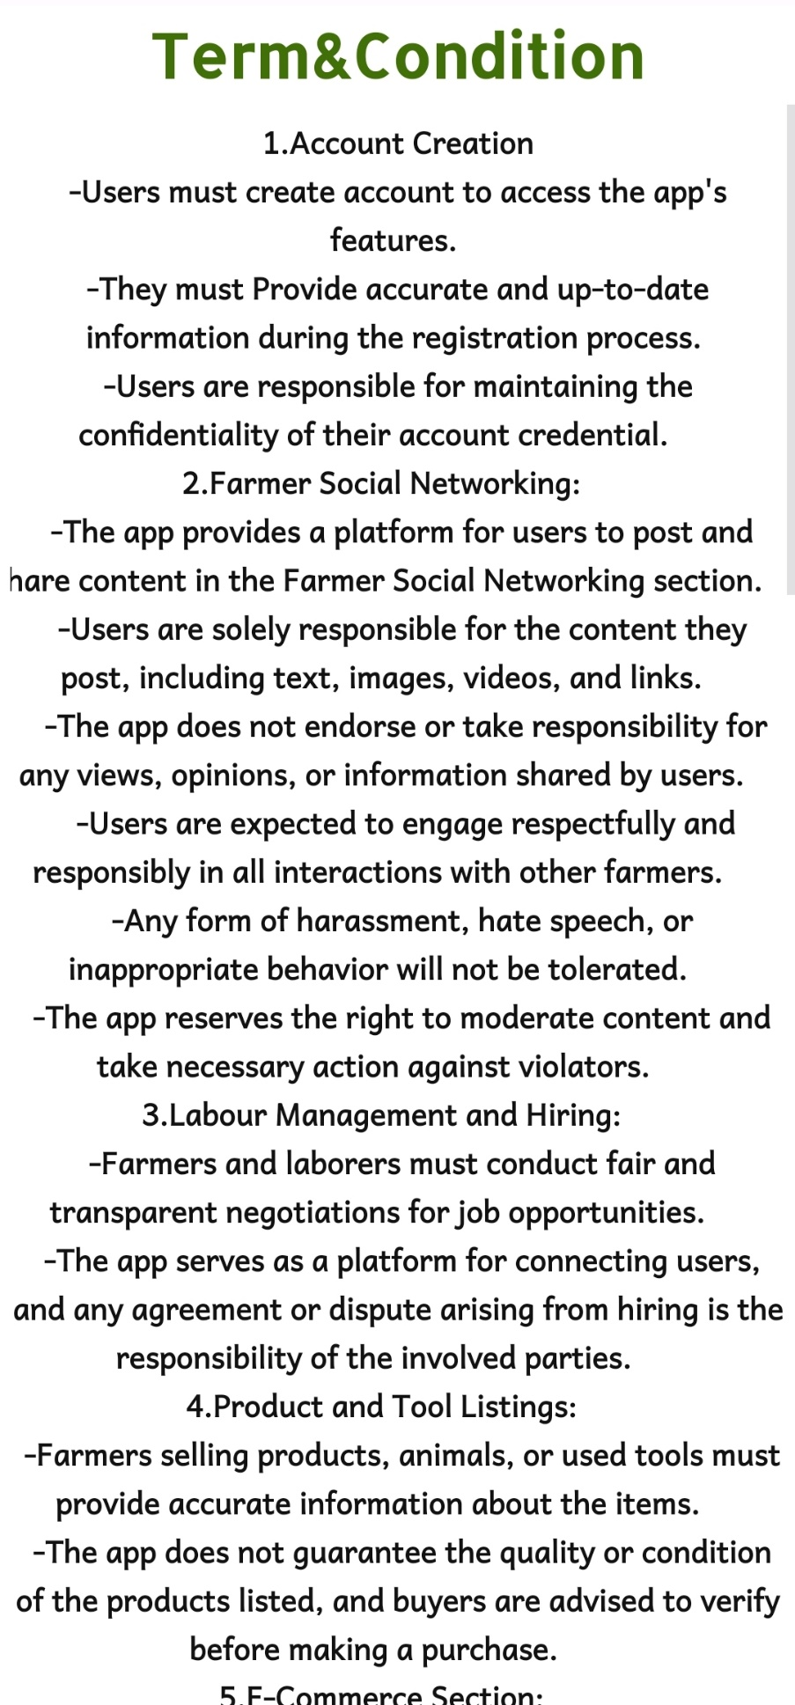

* **Admin Panel**

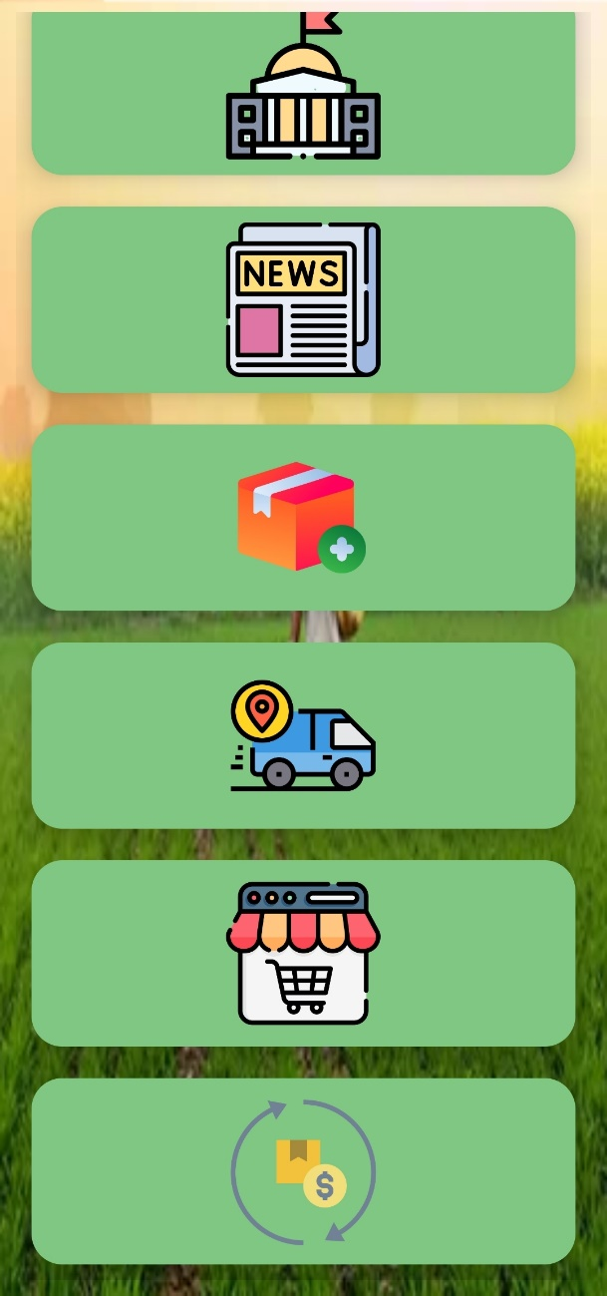

* **User List**

This module enables admin to view registered user and view data related to individual user. Admin is free to alter data.

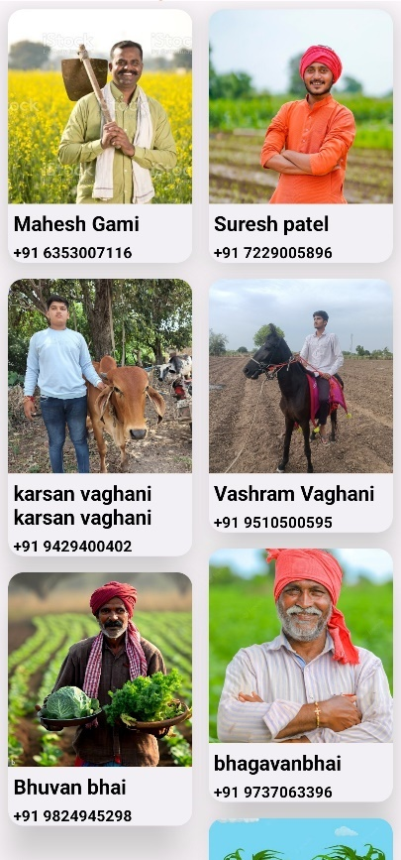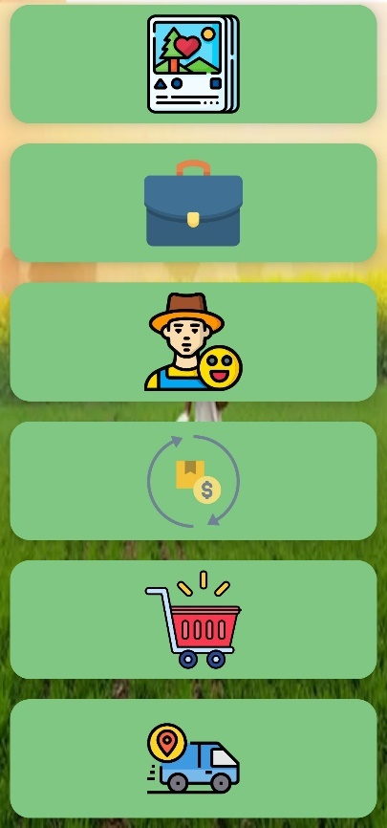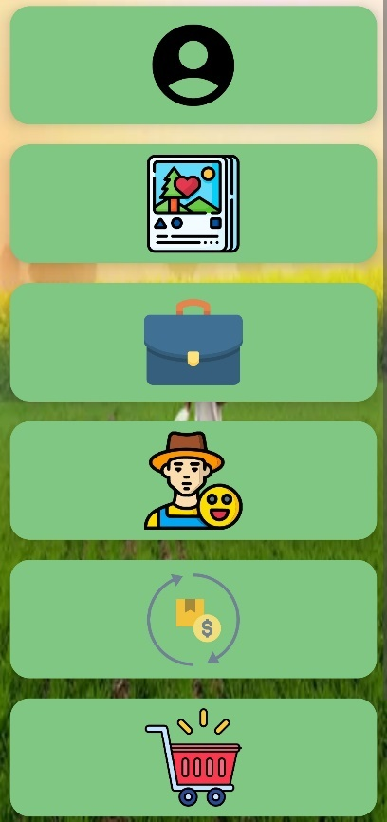

* **Government scheme**

Admin can see existing government scheme, delete them and can add new scheme.

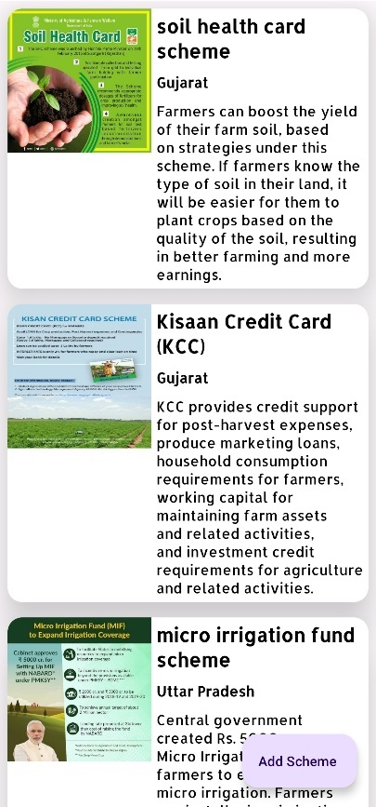 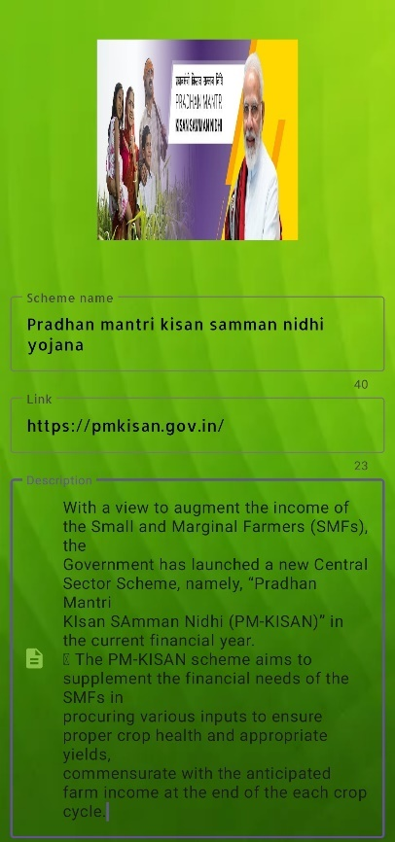 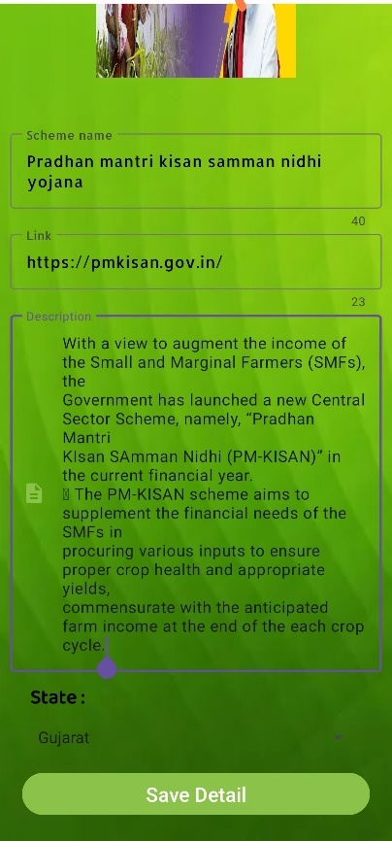

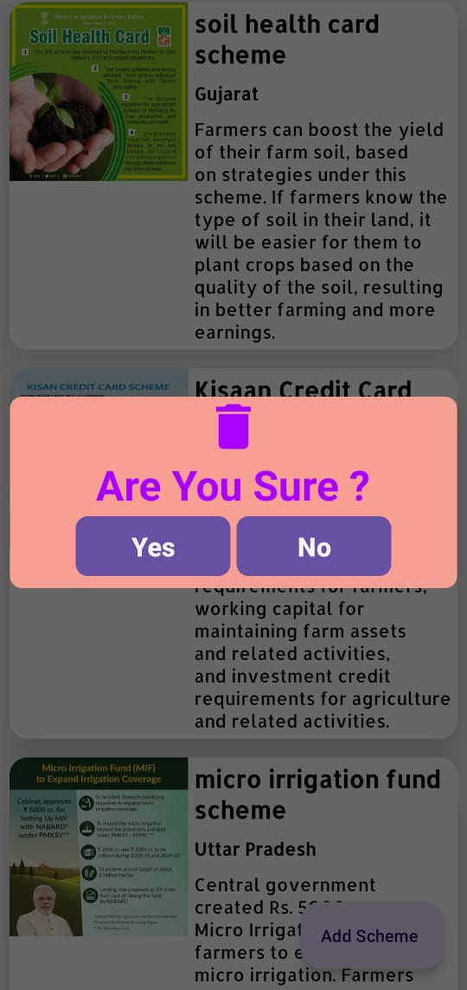

* **News**

Admin is responsible for publishing and maintaining the latest news.

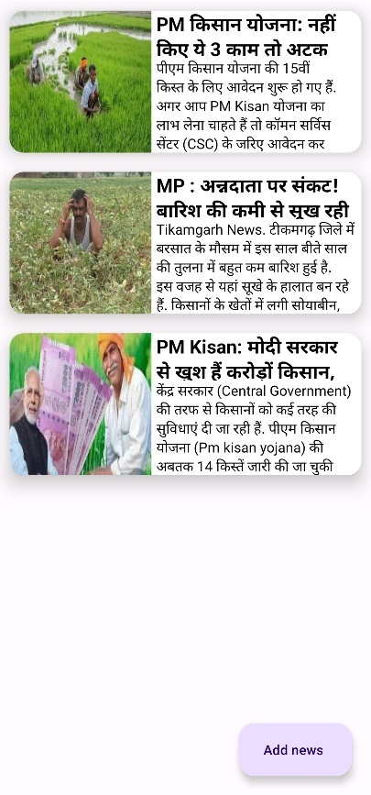 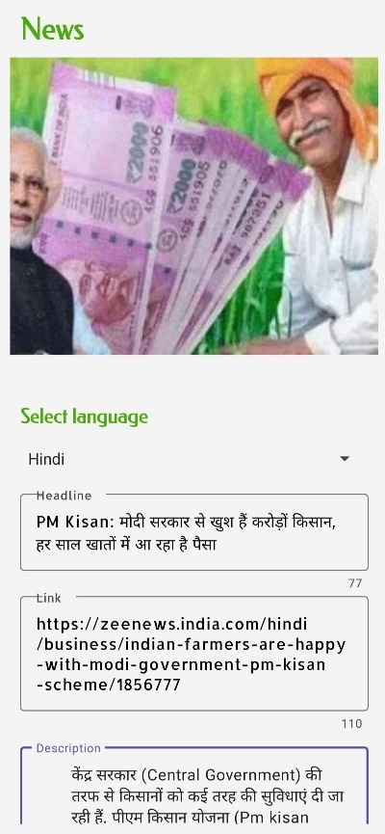 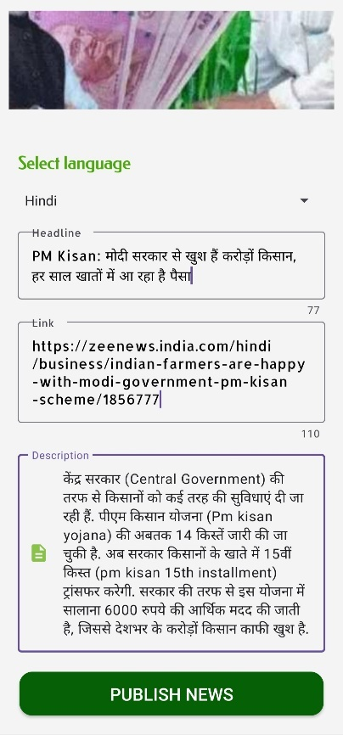

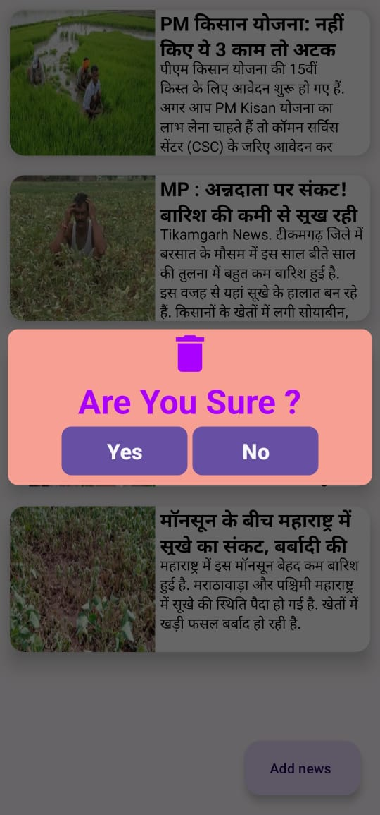

* **Add/View Ecommerce Product**

Admin can live Products on E commerce store.

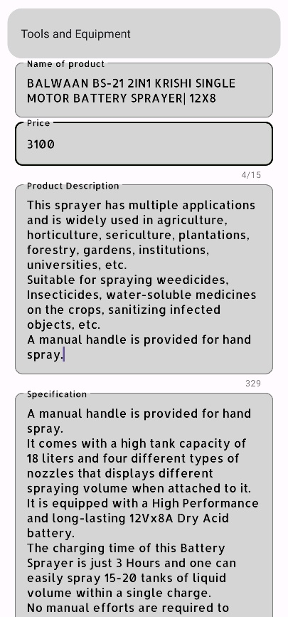 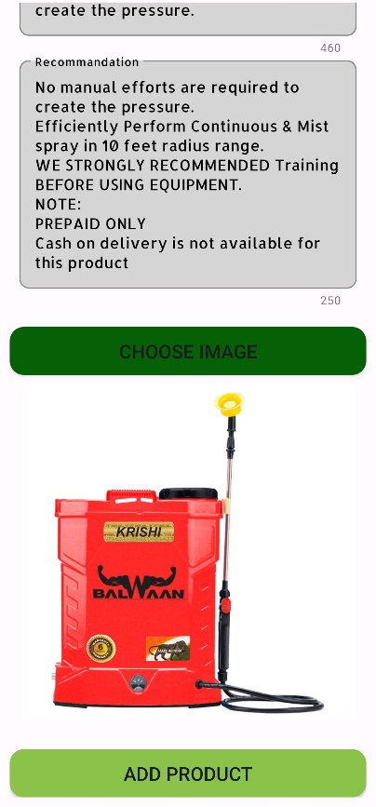 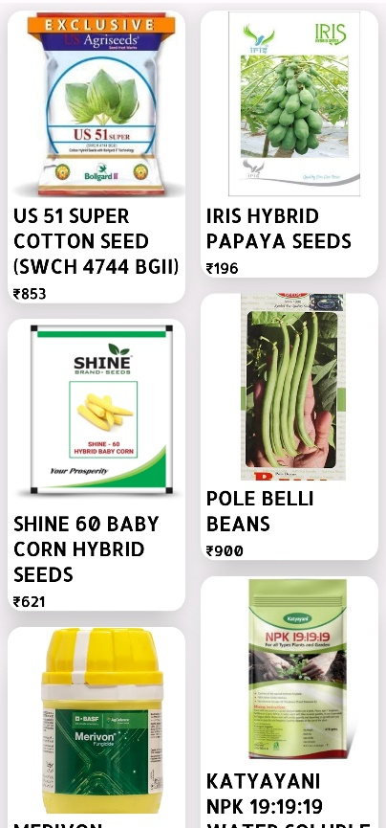

* **View Orders**

Admin can view Date wise orders of Product.

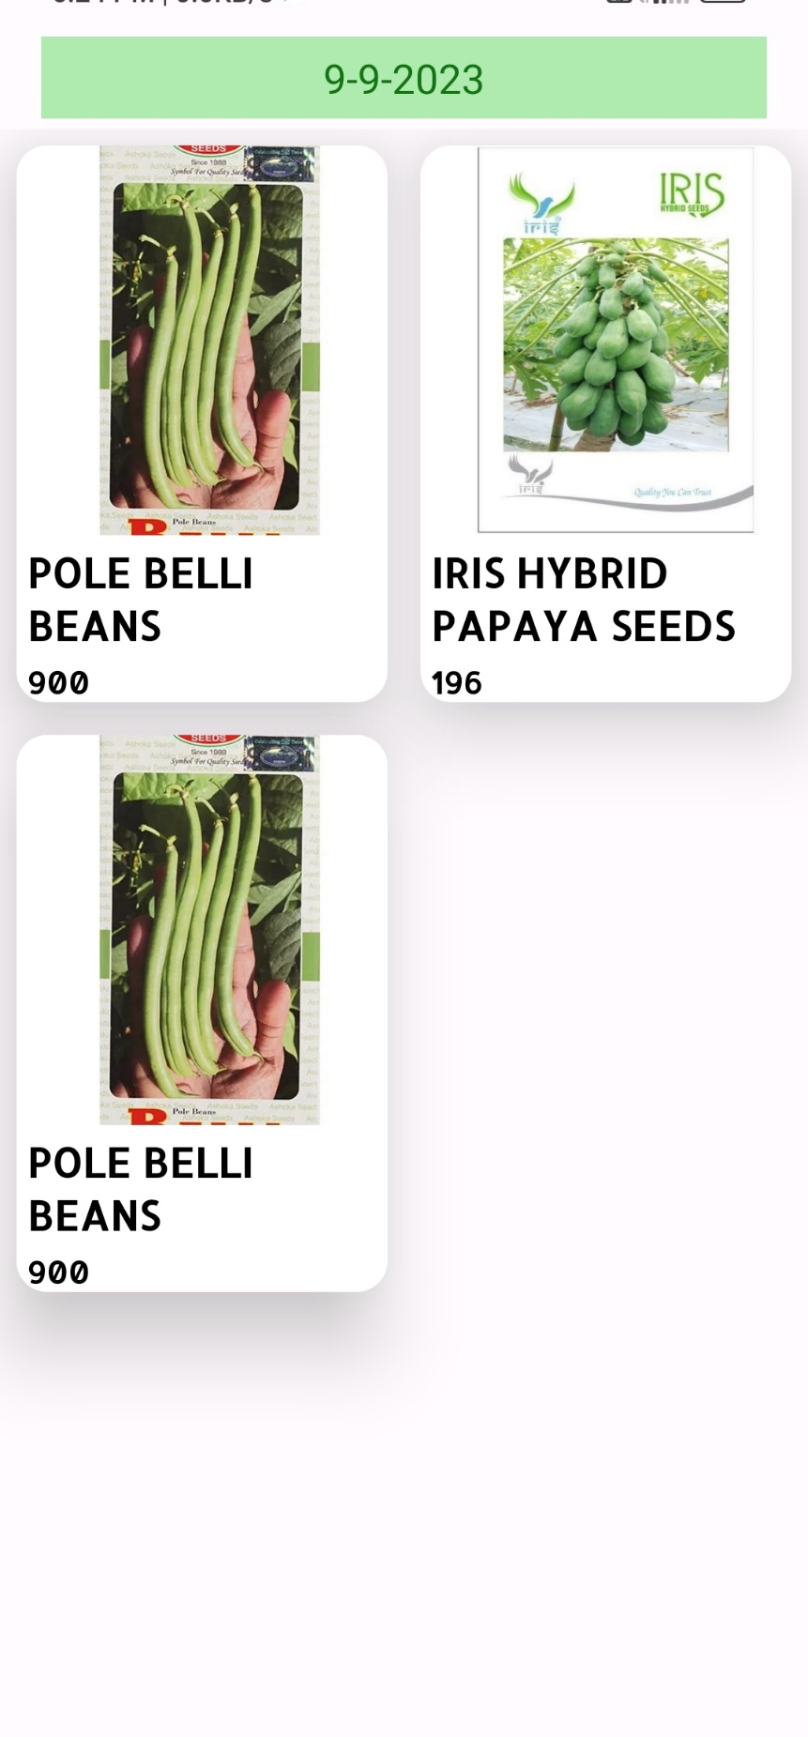

* **View Resell**

Admin Has Power to view/alter/delete resell data.

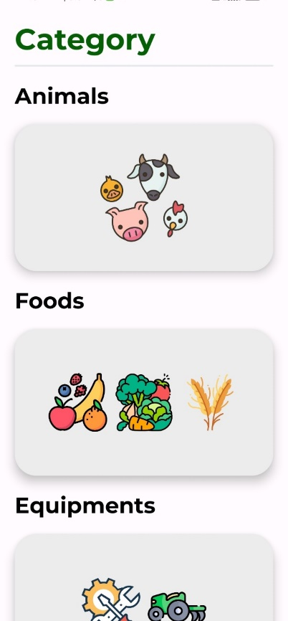 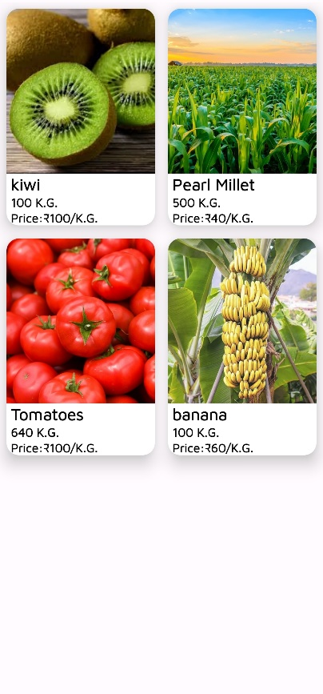 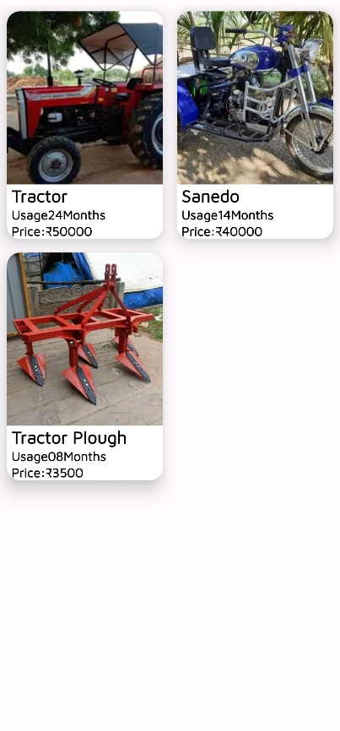

 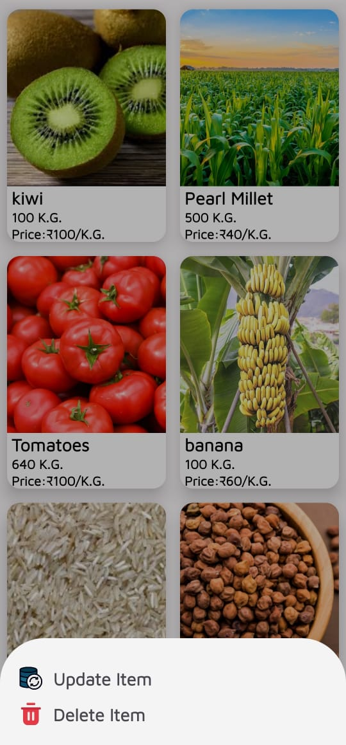 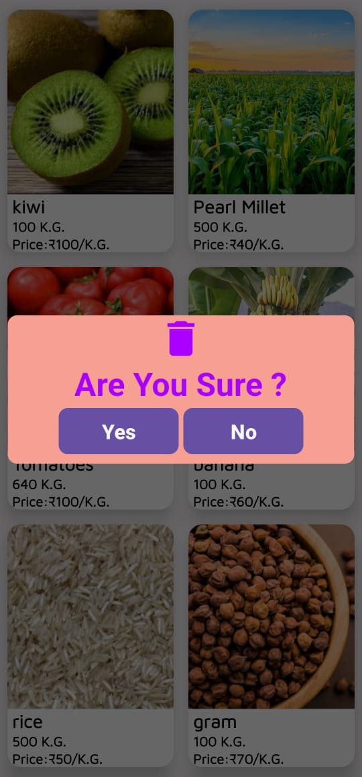

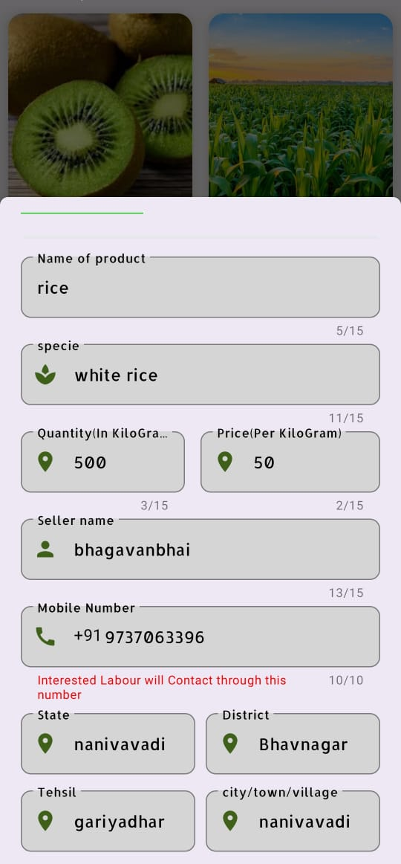 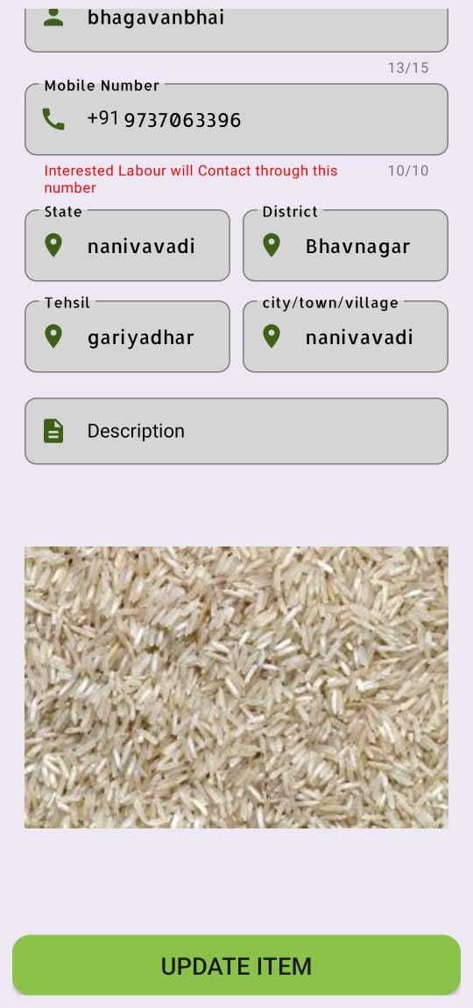

**9.References**

* <https://stackoverflow.com/>
* <https://www.youtube.com/>
* <https://www.geeksforgeeks.org/>
* <https://github.com/>
* <https://firebase.google.com/docs/auth/web/firebaseui>
* <https://developer.android.com/docs>



**Thank You**

|  |  |  |
| --- | --- | --- |
| Roll No | Student Name | SID |
| 747 | **BHALANI HIREN** | **21410454** |
| 764 | **BHUVA KISHAN** | **21410396** |
| 756 | **KATHIRIYA RISHIL** | **21410422** |
| 750 | **DHAMELIYA ABHI** | **21410493** |

Created by: